**ABSTRACT**

The Online Shopping is a web based application intended for online retailers. The main objective of this application is to make it interactive and its ease of use. It would make searching, viewing and selection of a product easier.

It contains a sophisticated search engine for users to search for products specific to their needs. The search engine provides an easy and convenient way to search for products where a user can Search for a product interactively and the search engine would refine the products available based on the user’s input.

The user can then view the complete specification of each product. They can also view the product reviews and also write their own reviews. The application also provides a drag and drop feature so that a user can add a product to the shopping cart by just one click on buy now.

The main emphasis lies in providing a user friendly search engine for effectively showing the desired results just one click behavior.

**PROJECT PROFILE**

Project Title : - **Online Shopping System**

Objective : - The main idea behind developing CRM is to monitor the sales efforts of any organization and thereby improving it. It also helps in capturing and sharing customer data in organization effectively.

Organization : - Niki Technologies, Ahmedabad.

Team size : - 1

Developed By : - Nayi Kiran N.

Project Guide : - Mr. Vijay Patel.

Mr. Jay Shah.

Software : - **Development Technology:** PHP

**Database**: MySQL

Submitted To : - Department Of Computer Science,

HNGU.

Patan – 384265.

**COMPANY PROFILE**

**Niki Technologies** specializes in developing Website, Face book Applications and Mobile Applications after gaining complete understanding about the client project requirements why he wants to design and develop website, look and feel of the website, its core functionality that client wants to have within its application.

We are offsure website design and Development Company expanding its service offerings to Mobile Application Development and Face book Application Development to satisfy its clients and their business needs.

**Niki Technologies** is one stop solution for you. Niki Technologies have team of PHP Developers who can create any website, application, solution using PHP Framework. Our PHP Developers can make impossible things possible with PHP.

We are development firm that help business creating their online presence since many years. Lets create yours using either dedicated resources or web professionals

**INDEX**

**Abstract 1**

**Project Profile 2**

**Company Profile 3**

1. **Introduction 7**
   1. Project Details
   2. Purpose
   3. Technology and Literature Review

1. **Project Management 14**
   1. Feasibility Study
      1. Technical feasibility
      2. Time feasibility

2.1.3 Operational feasibility

2.1.4 Implementation Feasibility

* 1. Project Planning
     1. Project Development Approach and Justification
     2. Project Plan
     3. Milestones and Deliverables

**3.0 System Requirements Study 20**

3.1 Study of Current System

3.2 Problems and Weaknesses of Current System

3.3 User Characteristics

3.4 Hardware and Software Requirements

**4.0 System Analysis 23**

* 1. Requirement Analysis
  2. Software Requirement Specification(SRS)

1. **System Design 32**
   1. Design Methodology
   2. System Architecture Design
      1. Use Case Diagram
      2. Class Diagram
      3. Sequence Diagram
      4. Activity Diagram
      5. Component Diagram
      6. Deployment Diagram

5.2 System Database Design

1. **User Manual 63**
2. **Testing 123**
   1. Testing Plan
   2. Testing Strategy
   3. Testing Methods

1. **Conclusion and Discussion 129**

* 1. **Discussion** 
     1. **Self Analysis of Project Viabilities**
     2. **Summary of Project work**

1. **Bibliography 131**

**Introduction 1**

* 1. **Project Details**

The Online Shopping is a web based application intended for online retailers. The main

objective of this application is to make it interactive and its ease of use. It would make

searching, viewing and selection of a product easier. It contains a sophisticated search

engine for user's to search for products specific to their needs.

* 1. **Purpose**

Shopping has long been considered a recreational activity by many. Shopping online is

no exception. The goal of this application is to develop a web based interface for online

Retailers. The system would be easy to use and hence make the shopping experience

Pleasant for the users. The goal of this application is

To develop an easy to use web based interface where users can search for products, view a complete description of the products and order the products.

• A search engine that provides an easy and convenient way to search for products

Specific to their needs. The search engine would list a set of products based on the

Search term and the user can further filter the list based on various parameters.

• An AJAX enabled website with the latest AJAX controls giving attractive and

Interactive look to the web pages and prevents the annoying post backs.

• Drag and Drop feature which would allow the users to add a product to or remove

A product from the shopping cart by dragging the product in to the shopping cart

Or out of the shopping cart.

• A user can view the complete specification of the product along with various

Images and also view the customer reviews of the product. They can also write

Their own reviews.

* 1. **Technology**

## PHP (Hypertext Preprocessor)

**PHP** is a general-purpose server-side scripting language originally designed for Web development to produce dynamic Web pages. It is one of the first developed server-side scripting languages to be embedded into an HTML source document, rather than calling an external file to process data. Ultimately, the code is interpreted by a Web server with a PHP processor module which generates the resulting Web page. It also has evolved to include a command-line interface capability and can be used in standalone graphical applications.PHP can be deployed on most Web servers and also as a standalone shell on almost every operating system and platform free of charge. A competitor to Microsoft's Active Server Pages (ASP) server-side script engine and similar languages, PHP is installed on more than 20 million Web sites and 1 million Web servers.

**Project Management 2**

**2.1 FEASIBILITY STUDY**

Project Management uses a systematic and disciplined approach to develop software. Project Management activities include: project planning, implementation of project components in a timely manner, review of project activities, and a listing of lessons learned during the project. These activities follow the typical life cycle of a software project.

Project management usually follows major phases including feasibility study, project planning, implementation, evaluation and support/maintenance.

The primary challenge of project management is to achieve all of the project goals and objectives while honoring the project constraints. Typical constraints are scope, time and budget. The secondary and more ambitious challenge is to optimize the allocation and integration of inputs necessary to meet pre-defined objectives.

A Software Project Management Plan (SPMP) can be used to outline the structure of the project and how it will be managed. The SPMP will outline all project management activities including configuration management and team management/roles.

Once scope has been identified it is reasonable to ask: “Can we build product or system to meet this scope? Is the project feasible?”

The main aim of the feasibility study activity is to determine whether it would be financially and technically feasible to develop the product. The feasibility study activity involves the analysis of the problem and the collection of relevant information related to the product such as the different items which would be input to the system, the processing required to be carried out on these data, the output data required to be produced by the system, as well as various constraints on the behavior of the system.

Preliminary investigation examine the project Feasibility, the likelihood the system will be useful to the organization. There are three basic tests of feasibility study for computation of a new system, and each one is equally important. These tests are

* + Technical feasibility
  + Time Schedule feasibility
  + Behavioral or Operational feasibility
  + Implementation feasibility

**2.1.1 Technical Feasibility**

* + Is the system easy to develop?
  + Is this system able to handle more clients at a same time?
  + Is system efficient to handle high data processing?
  + If system needs to expand capacity then all resources will be given so that system can perform faster than old system?
  + Is the proposed technology or solution practical?
  + Do we currently possess the necessary technology?
  + Do we possess the necessary technical expertise, and is the schedule reasonable?
  + Is relevant technology mature enough to be easily applied to our problem?
  + Assuming that required technology is practical, is it available in the information systems shop? If the technology is available, does it have the capacity to handle the solution?
  + If the technology is not available, can it be acquired?

**2.1.2 Time Schedule Feasibility**

* + It is a measure of how reasonable the project timetable is.
  + We may have the technology, but that doesn't mean we have the skills required to properly apply that technology. All information systems professionals can learn new technologies but that learning curve will enhance the technical feasibility of the project; at the same time, it will degrade the time schedule feasibility.
  + Given our technical expertise, are the project deadlines reasonable? Some projects are initiated with specific deadlines. You need to determine whether the deadlines are mandatory or desirable. If the deadlines are desirable rather than mandatory, the analyst can propose alternative schedules.
  + It is preferable (unless the deadline is absolutely mandatory) to deliver a properly functioning information system two months later than to deliver an error-prone, useless information system on time!

**2.1.3 Operational Feasibility**

* + Does current mode of operation provide adequate throughput and response time?
  + Does current mode provide end users and managers with timely, pertinent, accurate and usefully formatted information?
  + Does current mode of operation provide cost-effective information services to the business? Could there be a reduction in costs and/or an increase in benefits?
  + Does current mode of operation offer effective controls to protect against fraud and to guarantee accuracy and security of data and information?
  + Does current mode of operation make maximum use of available resources, including people, time and flow of forms?
  + Does current mode of operation provide reliable service? Is it flexible and expandable?
  + How do end-users and managers feel about the problem (solution)?
  + It's not only important to evaluate whether a system can work but also evaluate whether a system will work.
  + A workable solution might fail because of end user or management resistance.
  + Does management support the project?
  + How do the end users feel about their role in the new system?
  + Why end users or managers may resist or not use the system?
  + People tend to resist change. Can this problem be overcome? If so, how?
  + How will the working environment of the end users change?
  + Can or will end users and management adapt to the change?

**2.1.4 Implementation Feasibility**

To be judged feasible, a project proposal must pass these entire tests. Otherwise, it is not a feasible project. Our preliminary investigation revealed that the project is feasible in all this aspects.

The organization gets the following benefits by using the proposed Information system:

* + Greater speed in processing data.
  + Improved accuracy and consistency.
  + Faster information retrieval.
  + Reduced costs.
  + Better security.
  + Competitive advantage.
  + Enhanced communication.

**2.2 PROJECT PLANNING**

Once a project is found to be feasible, software project managers undertakes project planning. Project planning is undertaken and completed even before any development activity starts.

The objective of software project planning is to provide a framework that enables the manager to make reasonable estimates of resources, cost, and schedule. These estimates are made within a limited time frame at the beginning of a software project development and should be updated regularly as the project progresses.

**2.2.1 Project Development Approach and Justification**

The Requirements provide by the users are Software Requirement Specification as described above. The SRS documents are then revised, validated, authorized and approved by the users. The development commences after the approval phase i.e. after the signing off of the SRS documents. Thus, the SRS is concerned to be the most important document from user and developer prospective. The Developer will try to adhere to the requirements specified in the SRS documents in order to develop the required application.

**2.2.2 Project Plan**

This system of **Online Shopping System** is designed to follow the PROTOTYPE MODEL

**2.2.3 Milestones and Deliverables**

Milestones are identified in order to complete the entire project in the time duration. Milestones are identified for every module.

Table 2.1 Milestones and Deliverables

|  |  |  |
| --- | --- | --- |
| **PHASE** | **DELIVERABLES** | **PURPOSE** |
| System Requirement and Analysis | * Requirement Gathering and analysis. * Functional Specifications   Non Functional Specifications | It gives exact understanding of the user’s requirements. |
| System Design | * Database Design * Use Case Diagram * Class diagram * Sequence Diagram | It gives the logical structure that describes the system. |
| Implementation and Testing | The output obtained for the required functionality after implementing and doing various types of testing | It gives the required module |

**SYSTEM REQUIREMENT STUDY 3**

**3.1 STUDY OF CURRENT SYSTEM**

There are large numbers of commercial Online Shopping websites offering large number

Of products tailored to meet the shopping interests of large number of customers. These Online marketplaces have thousands of products listed under various categories.

**3.2 PROBLEMS AND WEAKNESSES OF CURRENT SYSTEM**

• The basic problems with the existing systems are the non-interactive environment

They provide to the users.

• The use of traditional user interfaces which make continuous post backs to the

Server; each post back makes a call to the server, gets the response and then

Refreshes the entire web form to display the result. This scenario adds an extra

Trade off causing a delay in displaying the results.

• A search engine that would display the results without allowing the users to

Further filter the results based on various parameters.

• Use of traditional and non user friendly interfaces that are hard to use.

**3.3 USER CHARACTERISTICS**

There are 3 users in our system:

**(1)** **Administrator**

The administrator will have all rights to handle all users. He will have special ID and Password using which he/she can add, active/inactive, update user data .Administrator can do several things.

* Add User
* Inactive User
* Create/Update Product
* Create/ Update Category
* Create/ Update Sub Category
* Create/ Update Material
* Create/ Update Design
* Manage Cart
* Manage FAQs
* Login/Logout
* Manage Reports
* Manage Order
* Change Password and etc.

**(2) Registered User**

* Search Product.
* View Product Detail.
* View Wish list.
* Add To Cart.
* Manage Cart.
* Edit Billing and Shipping detail.
* Checkout.
* Login/Logout.
* Change Password and etc.

**(3) Guest User**

* Search Product.
* View Product Detail.
* View Wish list.
* Add To Cart.
* Manage Cart.

**3.4 HARDWARE AND SOFTWARE REQUIEREMENTS**

**Table 3.1 Tools and Technology**

|  |  |
| --- | --- |
| **Development technologies** | PHP(Hypertext Preprocessor) |
| **Application server** | Wamp Server |
| **Database** | MySQL Server |
| **Operating system** | Windows XP Profession Edition and Above |
| **Web browser** | Internet Explorer 7.0 and above |
| **Hardware** | P-IV 2.4, 1 GB RAM, 80 GB HDD |

**SYSTEM ANALYSIS 4**

**4.1 REQUIREMENT ANALYSIS:**

**Objectives of SRS**

* To identify the system that will be produced.
* To describe what the system will do and if necessary what they will not do.
* To describe/specify the benefits, objectives and goals of the System
* To ensure that all functional requirements of the system are captured.
* To ensure that requirements for the systems are defined and clearly understood.
* To track the requirements with the User Acceptance Test Cases.
  1. **SOFTWARE REQUIREMENT SPECIFICATION (SRS):** 
     1. **Security Module**

**R1:- Admin Login**

**Input: -** Username, Password

**Process: -** Verify Username and password from database.

**Output: -** Admin Panel Home.

**Alternate Scenario: -** If Username and/or password incorrect then display error message.

* + 1. **Admin Module**

**R2:- Add Admin**

**Input:** - Username, Password and Other Detail.

**Process: -** Create new Admin and entry in Database.

**Output: -** Conformation message.

**Alternate Scenario: -** If any error then display error message.

**R3:- Update Admin**

**Input:** - First name

**Process: -** Update Admin Data and entry in Database.

**Output: -** Conformation message.

**Alternate Scenario: -** If Admin does not exit then display error message.

**R4:- Add Category**

**Input:** - Category Name.

**Process: -** Create new Category and entry in Database.

**Output: -** Conformation message.

**Alternate Scenario: -** If any error then display error message.

**R5:- Update Category**

**Input:** - Category Name

**Process: -** Update Category Data and entry in Database.

**Output: -** Conformation message.

**Alternate Scenario: -** If Category does not exit then display error message

**R6:- Add Subcategory**

**Input:** - Subcategory Name, Category Name.

**Process: -** Create new Subcategory and entry in Database.

**Output: -** Conformation message.

**Alternate Scenario: -** If any error then display error message.

**R7:- Update Subcategory**

**Input:** - Subcategory Name

**Process: -** Update Subcategory Data and entry in Database.

**Output: -** Conformation message.

**Alternate Scenario: -** If Subcategory does not exit then display error message

**R8:- Add Product**

**Input:** - Product Name And Other Product Detail.

**Process: -** **-** Create new Product and entry in Database.

**Output: -** Conformation message.

**Alternate Scenario: -** If any error then display error message.

**R9:- Update Product**

**Input:** - Product Name

**Process: -** Update Product Data and entry in Database.

**Output: -** Conformation message.

**Alternate Scenario: -** If Product does not exit then display error message

**R10:- Add Brand**

**Input:** - Brand Name And Other Brand Detail.

**Process: -** **-** Create new Brand and entry in Database.

**Output: -** Conformation message.

**Alternate Scenario: -** If any error then display error message.

**R11:- Update Brand**

**Input:** - Product Name

**Process: -** Update Brand Data and entry in Database.

**Output: -** Conformation message.

**Alternate Scenario: -** If Brand does not exit then display error message.

**R12:- Logout**

**Input:** - AdminId

**Process: -** Logout the system and move from start page.

**Output: -** Conformation message.

* + 1. **User Module**

**R13:- User Registration**

**Input:** - User Detail.

**Process: -** **-** Create new User and entry in Database.

**Output: -** Conformation message.

**Alternate Scenario: -** If any error then display error message.

**R13:- User Login**

**Input:** - E-mail and Password.

**Process: -** Verify Username and password from database.

**Output: -** Homepage.

**Alternate Scenario: -** If Email and/or password incorrect then display error message.

**R14:- Update User Detail**

**Input:** - UserId and User Detail.

**Process: -** Update User Detail and entry in Database.

**Output: -** Conformation message.

**Alternate Scenario: -** If User does not exit then display error message.

**R14:- Change Password**

**Input:** - UserId, old password, new password.

**Process: -** Check input data and update in database.

**Output: -** Conformation message.

**Alternate Scenario: -** If input data does not exit then display error message.

**R14:- Edit Address detail**

**Input:** - Address detail of user

**Process: -** **-** Update Address Detail and entry in Database.

**Output: -** Conformation message.

**Alternate Scenario: -** If input data does not exit then display error message.

**R14:- Search Product**

**Input:** - Product Name or other related information.

**Process: -** Search and select Product detail from Database.

**Output: -** Show all Product which match with input.

**Alternate Scenario: -** If Product does not exit then display no product found.

**R15:- View Product Detail**

**Input:** - Product Id or other related information.

**Process: -** Select Product detail from Database.

**Output: -** Show Product of particular product match with input.

**Alternate Scenario: -** If Product does not exit then display error.

**R16:- Manage Cart**

**Input:** - UserId, CartId, and Other Detail.

**Process: -** insert update delete from database on basis of userid and cartid.

**Output: -** Show Shopping cart with the updation of database.

**Alternate Scenario: -** If userid or cartid does not exit then display error.

**R12:- Logout**

**Input:** - Userid

**Process: -** Logout the system and move from start page.

**Output: -** Conformation message.

**SYSTEM DESIGN 5**

* 1. **DESIGN METHODOLOGY**

Design Methodology meand the method that we have followed during the whole project. Following are some of the methods which are followed by us during the whole period.

* Object Oriented
* UML

We have followed Object Oriented Methodology for our product. In it every entity is an object of the class. And we have defined methods and operation that is perform on that object. As we have followed N-tire approaches for the systemimplementation the communication between each of the three layers must be through the layer by using the functions and methods.

Our main concern during project was the analysis and design through the UML, so called Unified Modeling Language which is the widely accepted modeling tool for the system analysis and design.

The whole software development industry has been explosive, partly due to the revolutionary nature of the software itself, which is driven by world wide business and competition. For those who are responsible for delivering these revolutionary to make our current skill and experienced obsolate. Consequently, most study is focused on programming rather than on engineering, with practitioners gravitating toward the tangible implementation products and away from abstract and design artifacts. But it is this very tendency that has led to many failed system and disastrouss problems. This need for more mature approach is behind our drive for UML.

One way to organize the design of any product by using views. UML provides three views to organize the system. These views are complementary to each other in providing clear of requirements and scope of the product.

# Functional View

In the functional view we include both Use Case and Activity Diagrams. We keep them together because they are used together to model how the system is supposed to work.

Use Cases defines the functions that the system must provide. The *functions* are expressed first as goals and then goals are fleshed out in a narrative to describe what each use case is expected to do to achieve each goal. We use the method to write narrative for Use Cases, because the words gives clear indication and understanding of clients’ expectation from the product, but we draw the logic with an activity diagram because it is useful for modeling a work flow or a business process. It can be very useful when working with clients to determine how things are or to be done. We can also use the activity diagram to assess the complexity of the application, and to verify the internal consistency of our Use Case definitions. Later in design, we need to specify the implementation details for methods. When the details become complicated, being able to draw them out using the Activity Diagram makes the logic easier to understand.

In brief,

* The **Use Case** narratives describe the feature that the users expect the system to provide.
* The Activity Diagrams describes including sequential tasks, conditional logic and concurrency. These diagrams are like a flow chart, but it has been enhanced for use with object modeling.

# Static View

The static view includes that diagram that provides a snapshot of the elements of the system but don’t tell you how the elements will behave. So It is very much like blue print. Blue prints are comprehensive, but they only show what remains stationary, hence we use the term static view. The class diagrams provide a fixed look at every resource (class) and its features.

In brief,

* The ***Class diagrams*** is the foundation for modeling the rules about types of objects (classes), the source for code generation, and the target for reverse engineering.

# Dynamic View

We mentioned that the static view is like the blue print. In the blue print we can see the pieces of the system but what we can’t see is how all these pieces work together. If we could see a model of interactions between all those things on the blue print we would know that if one action is taken what would be the reaction of the system. So now that’s dynamic. The Dynamic view include diagram that reveals how objects interact with one another in response to the environment. We have used sequence diagrams for representing the real dynamic view. This diagram is referred to as interaction diagram. We specifically designed it to describe how objects talk to each other.

In brief

* For modeling objects interaction we have used ***sequence diagrams.***
* For represent the flow form one activity to another activity we have used ***Activity diagrams.***
  1. **SYSTEM ARCITECTURE DESIGN**
     1. **Use-Case Diagram**





* + 1. **Class Diagram**



**All Classes**

**User Class**



**Admin Class**



**Category Class**



**SubCategory Class**



**Product Quantity Class**



**Product Class**



**Order Detail Class**



**Shopping cart Class**



**Payment Class**



* + 1. **Sequence Diagram**
* **ADMIN**



* **Registered User**
* **Guest User**



1. **Activity Diagram**

* **Admin**



* **User**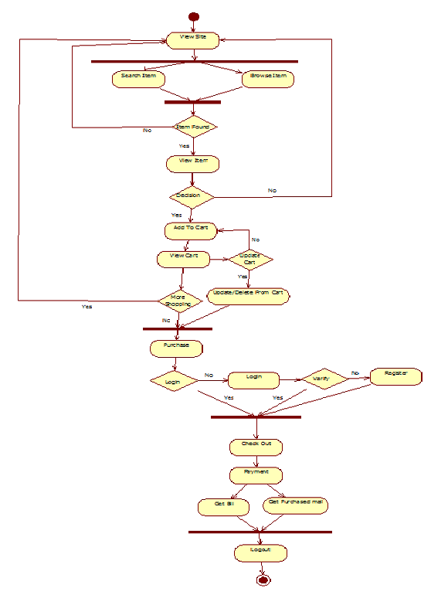
  1. **SYSTEM DATABASE DESIGN**

|  |  |  |  |  |  |
| --- | --- | --- | --- | --- | --- |
| **Table** | | **User_Master** | | | |
| **Primary Key** | | UserID | | | |
| **Description** | | It is used to store the details of User. | | | |
|  | | | | | |
| **Field Name** | **Data Type** | | **Key** | **Allow Null** | **Description** |
| UserID | Int | | Primary Key | No | Unique User ID |
| Firstname | varchar(20) | |  | No | Store First Name |
| Lastname | varchar(25) | |  | No | Store Last Name |
| Gender | varchar(20) | |  | No | Store Gender Of User |
| Email | varchar(50) | |  | No | Store E-mail Of User |
| Password | varchar(25) | |  | No | Store Password Of User |
| Bdate | date | |  | No | Store Birth-Date Of User |
| Mobile | Int | |  | No | Store Mobile No |
| Bill_Address | varchar(50) | |  | No | Store Billing Address |
| Bill_Country | varchar(20) | |  | No | Store Billing County |
| Bill_StateId | Int | | FK_(State_master) | No | Store Billing StateID |
| Bill_City | varchar(20) | |  | No | Store Billing City |
| Bill_Pincode | Int | |  | No | Store Billing Pincode |
| Ship_Address | varchar(50) | |  | No | Store Shipping Address |
| Ship _Country | varchar(20) | |  | No | Store Shipping County |
| Ship _StateId | Int | | FK_(State_master) | No | Store Shipping StateID |
| Ship _City | varchar(20) | |  | No | Store Shipping City |
| Ship _Pincode | Int | |  | No | Store Shipping Pincode |
| Image |  | |  | No | Store image |
| Last_Login | timestamp | |  | No | Store Time Of Last Login |
| Status | Int | |  | No | Store Status Of User |

|  |  |  |  |  |  |
| --- | --- | --- | --- | --- | --- |
| **Table** | | **State_Master** | | | |
| **Primary Key** | | StateId | | | |
| **Description** | | It is used to store the details of State. | | | |
|  | | | | | |
| **Field Name** | **Data Type** | | **Key** | **Allow Null** | **Description** |
| StateId | Int | | Primary Key | No | Store StateId |
| State_Name | Varchar(25) | |  | No | Store State_Name |

|  |  |  |  |  |  |
| --- | --- | --- | --- | --- | --- |
| **Table** | | **Admin_Master** | | | |
| **Primary Key** | | AdminId | | | |
| **Description** | | It is used to store the details of Admin. | | | |
|  | | | | | |
| **Field Name** | **Data Type** | | **Key** | **Allow Null** | **Description** |
| AdminId | Int | | Primary Key | No | Unique Admin Id |
| Username | Varchar(20) | |  | No | Store Username |
| Password | Varchar(20) | |  | No | Store Password |
| Firstname | Varchar(20) | |  | No | Store Firstname |
| Lastname | Varchar(20) | |  | No | Store Lastname |
| Email | Varchar(30) | |  | No | Store Email |
| AdminRole | Varchar(20) | |  | No | Store Adminrole |
| LastLogin | date | |  | No | Store Last Login time |
| Status | int | |  | No | Store Status |

|  |  |  |  |  |  |
| --- | --- | --- | --- | --- | --- |
| **Table** | | **Category_Master** | | | |
| **Primary Key** | | CategoryId | | | |
| **Description** | | It is used to store the details of Category. | | | |
|  | | | | | |
| **Field Name** | **Data Type** | | **Key** | **Allow Null** | **Description** |
| CategoryId | Int | | Primary Key | No | Store CategoryId |
| Category_Name | Varchar(25) | |  | No | Store Category _Name |

|  |  |  |  |  |  |
| --- | --- | --- | --- | --- | --- |
| **Table** | | **SubCategory_Master** | | | |
| **Primary Key** | | SubCategoryId | | | |
| **Description** | | It is used to store the details of SubCategory. | | | |
|  | | | | | |
| **Field Name** | **Data Type** | | **Key** | **Allow Null** | **Description** |
| SubCategoryId | Int | | Primary Key | No | Store SubCategoryId |
| CategoryId | Int | | FK_(Categoty_master) | No | Store CategoryId |
| SubCategory_Name | Varchar(25) | |  | No | Store SubCategory _Name |

|  |  |  |  |  |  |
| --- | --- | --- | --- | --- | --- |
| **Table** | | **Size_Master** | | | |
| **Primary Key** | | SizeId | | | |
| **Description** | | It is used to store the details of Size. | | | |
|  | | | | | |
| **Field Name** | **Data Type** | | **Key** | **Allow Null** | **Description** |
| SizeId | Int | | Primary Key | No | Store SizeId |
| Size_Name | Varchar(25) | |  | No | Store Size _Name |

|  |  |  |  |  |  |
| --- | --- | --- | --- | --- | --- |
| **Table** | | **Color_Master** | | | |
| **Primary Key** | | ColorId | | | |
| **Description** | | It is used to store the details of Color. | | | |
|  | | | | | |
| **Field Name** | **Data Type** | | **Key** | **Allow Null** | **Description** |
| ColorId | Int | | Primary Key | No | Store ColorId |
| Color_Name | Varchar(25) | |  | No | Store Color _Name |

|  |  |  |  |  |  |
| --- | --- | --- | --- | --- | --- |
| **Table** | | **Design_Master** | | | |
| **Primary Key** | | DesignId | | | |
| **Description** | | It is used to store the details of Design. | | | |
|  | | | | | |
| **Field Name** | **Data Type** | | **Key** | **Allow Null** | **Description** |
| DesignId | Int | | Primary Key | No | Store DesignId |
| DesignName | Varchar(25) | |  | No | Store Design _Name |

|  |  |  |  |  |  |
| --- | --- | --- | --- | --- | --- |
| **Table** | | **Collar_Master** | | | |
| **Primary Key** | | CollarID | | | |
| **Description** | | It is used to store the details of Collar And Neck. | | | |
|  | | | | | |
| **Field Name** | **Data Type** | | **Key** | **Allow Null** | **Description** |
| CollarID | Int | | Primary Key | No | Store CollarID |
| CollarName | Varchar(25) | |  | No | Store Collar _Name |

|  |  |  |  |  |  |
| --- | --- | --- | --- | --- | --- |
| **Table** | | **Material_Master** | | | |
| **Primary Key** | | MaterialId | | | |
| **Description** | | It is used to store the details of Material. | | | |
|  | | | | | |
| **Field Name** | **Data Type** | | **Key** | **Allow Null** | **Description** |
| MaterialId | Int | | Primary Key | No | Store MaterialId |
| Material _Name | Varchar(25) | |  | No | Store Material _Name |

|  |  |  |  |  |  |
| --- | --- | --- | --- | --- | --- |
| **Table** | | **Stock_Master** | | | |
| **Primary Key** | | Stock_ID | | | |
| **Description** | | It is used to store the details of Product Stock. | | | |
|  | | | | | |
| **Field Name** | **Data Type** | | **Key** | **Allow Null** | **Description** |
| Stock_ID | varchar(20) | | Primary Key | No | Store Stock ID |
| Product_ID | varchar(20) | | FK_(Product_Master) | No | Store Product ID |
| Total_Stock | int | |  | No | Store Total Stock |

|  |  |  |  |  |  |
| --- | --- | --- | --- | --- | --- |
| **Table** | | **Product_Master** | | | |
| **Primary Key** | | ProductID | | | |
| **Description** | | It is used to store the details of Product. | | | |
|  | | | | | |
| **Field Name** | **Data Type** | | **Key** | **Allow Null** | **Description** |
| ProductId | Int | | Primary Key | No | Unique Admin Id |
| ProductName | Varchar(20) | |  | No | Store ProductName |
| CategotyId | Int | | FK_(Category_master) | No | Store CategotyId |
| SubCategotyId | Int | | FK_(Subcategory_master) | No | Store SubCategotyId |
| BrandId | Int | | FK_(Brand_master) | No | Store BrandId |
| MaterialId | Int | | FK_(Material_master) | No | Store MaterialId |
| DesignId | Int | | FK_(Design_master) | No | Store DesignId |
| NeckId | Int | | FK_(Neck_master) | No | Store NeckId |
| ProductImage | text | |  | No | Store Product Image |
| ProductPrice | Int | |  | No | Store Product Price |
| Discount Offer | Int | |  | No | Store Discount |

|  |  |  |  |  |  |
| --- | --- | --- | --- | --- | --- |
| **Table** | | **Product_Quantity_Master** | | | |
| **Primary Key** | | QuantityId | | | |
| **Description** | | It is used to store the details of Quantity | | | |
|  | | | | | |
| **Field Name** | **Data Type** | | **Key** | **Allow Null** | **Description** |
| QuantityId | Int | | Primary Key | No | Store QuantityId |
| ProductId | Int | | FK_(Product_master) | No | Store ProductId |
| SizeId | Int | | FK_(Size_master) | No | Store SizeId |
| ColorId | Int | | FK_(Color_master) | No | Store ColorId |
| Quantity | Int | |  | No | Store Quantity |
| SubCategoryId | Int | | FK_(SubCategoty_master) | No | Store SubCategoryId |

|  |  |  |  |  |  |
| --- | --- | --- | --- | --- | --- |
| **Table** | | **Shoppingcart_Master** | | | |
| **Primary Key** | | CartId | | | |
| **Description** | | It is used to store the details of Shopping Items Of User. | | | |
|  | | | | | |
| **Field Name** | **Data Type** | | **Key** | **Allow Null** | **Description** |
| CartId | Int | | Primary Key | No | Store CartId |
| UserId | Int | | FK_(User_master) | No | Store UserId |
| ProductId | Int | | FK_(Product_master) | No | Store ProductId |
| Quantity | Int | |  | No | Store Quantity |
| SizeId | Int | | FK_(Size_master) | No | Store SizeId |

|  |  |  |  |  |  |
| --- | --- | --- | --- | --- | --- |
| **Table** | | **Wishlist_Master** | | | |
| **Primary Key** | | WishlistId | | | |
| **Description** | | It is used to store the details of Wishlist Of User. | | | |
|  | | | | | |
| **Field Name** | **Data Type** | | **Key** | **Allow Null** | **Description** |
| WishlistId | Int | | Primary Key | No | Store WishlistId |
| UserId | Int | | FK_(User_master) | No | Store UserId |
| ProductId | Int | | FK_(Product_master) | No | Store ProductId |
| ProductPrice | Int | | FK_(Product_master) | No | Store ProductPrice |
| ProductName | Varchar(20) | | FK_(Product_master) | No | Store ProductName |
| ProductImage | text | | FK_(Product_master) | No | Store ProductImage |

|  |  |  |  |  |  |
| --- | --- | --- | --- | --- | --- |
| **Table** | | **FeedBack_Master** | | | |
| **Primary Key** | | FeedBackId | | | |
| **Description** | | It is used to store the details of Feedback. | | | |
|  | | | | | |
| **Field Name** | **Data Type** | | **Key** | **Allow Null** | **Description** |
| FeedbackId | Int | | Primary Key | No | Store FeedBackId |
| UserId | Int | | FK_(User_master) | No | Store UserId |
| FirstName | Int | | FK_(User_master) | No | Store FirstName |
| LastName | Int | | FK_(User_master) | No | Store LastName |
| E-mail | Varchar(20) | | FK_(User_master) | No | Store E-mail |
| Subject | Varchar(20) | |  | No | Store Subject |
| Comments | Varchar(255) | |  | No | Store Comments |

|  |  |  |  |  |  |
| --- | --- | --- | --- | --- | --- |
| **Table** | | **Order_Detail_Master** | | | |
| **Primary Key** | | OrderId | | | |
| **Description** | | It is used to store the details of Order | | | |
|  | | | | | |
| **Field Name** | **Data Type** | | **Key** | **Allow Null** | **Description** |
| OrderId | Int | | Primary Key | No | Store OrderId |
| TransactionId | Int | | FK_(Payment_master) | No | Store TransactionId |
| UserId | Int | | FK_(Payment_master) | No | Store UserId |
| OrderTime | Timestamp | | FK_( Payment _master) | No | Store OrderTime |
| Confirm | Int | | FK_( Payment _master) | No | Store Confirm |
| Totalamount | Int | | FK_( Payment _master) | No | Store Totalamount |
| Status | Int | |  | No | Store Status |

|  |  |  |  |  |  |
| --- | --- | --- | --- | --- | --- |
| **Table** | | **Payment_Master** | | | |
| **Primary Key** | | PaymentId | | | |
| **Description** | | It is used to store the details of Payment. | | | |
|  | | | | | |
| **Field Name** | **Data Type** | | **Key** | **Allow Null** | **Description** |
| PaymentId | Int | | Primary Key | No | Unique Payment Id |
| TransactionId | Int | |  | No | Store TransactionId |
| TransactionType | varchar(25) | |  | No | Store TransactionType |
| PaymentType | varchar(20) | |  | No | Store PaymentType |
| CurrencyCode | varchar(50) | |  | No | Store CurrencyCode |
| PaymentStatus | varchar(25) | |  | No | Store PaymentStatus |
| OrderTime | date | |  | No | Store OrderTime |
| ACK | varchar(25) | |  | No | Store ACK |
| Email | varchar(50) | | FK_(User_master) | No | Store Email |
| UserId | Int | | FK_(User_master) | No | Store UserId |
| FirstName | varchar(20) | | FK_(User_master) | No | Store FirstName |
| LastName | varchar(20) | | FK_(User_master) | No | Store LastName |
| ProductId | Int | | FK_(Product_master) | No | Store ProductId |
| ProductSize | Int | | FK_( Product _master) | No | Store ProductSize |
| Product_Qty | Int | | FK_( Product _master) | No | Store Product_Qty |
| ProductPrice | Int | | FK_( Product _master) | No | Store ProductPrice |
| ShipToAddress | varchar(20) | | FK_(User_master) | No | Store ShipToAddress |
| ShipToCity | varchar(20) | | FK_(User_master) | No | Store ShipToCity |
| ShipToState | varchar(20) | | FK_(User_master) | No | Store ShipToState |
| ShipToCountry | varchar(20) | | FK_(User_master) | No | Store ShipToCountry |
| ShipToZip | Int | | FK_(User_master) | No | Store ShipToZip |
| TotalAmount | Int | |  | No | Store TotalAmount |

**USER MANUAL 6**

1. **Home Page**

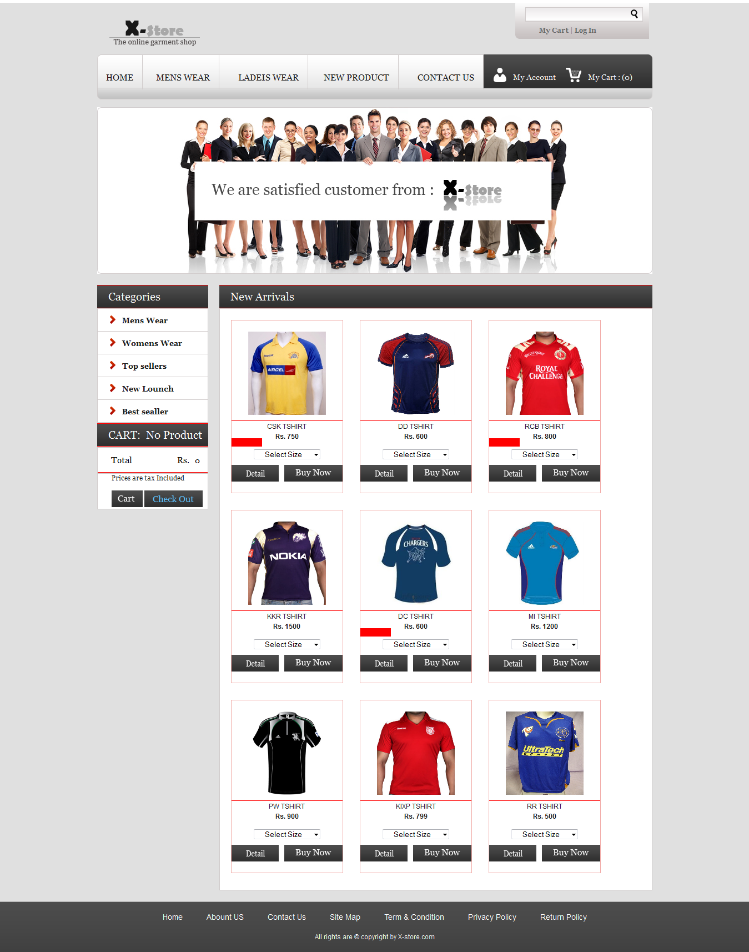

1. **Mens Wear Subcategory View**

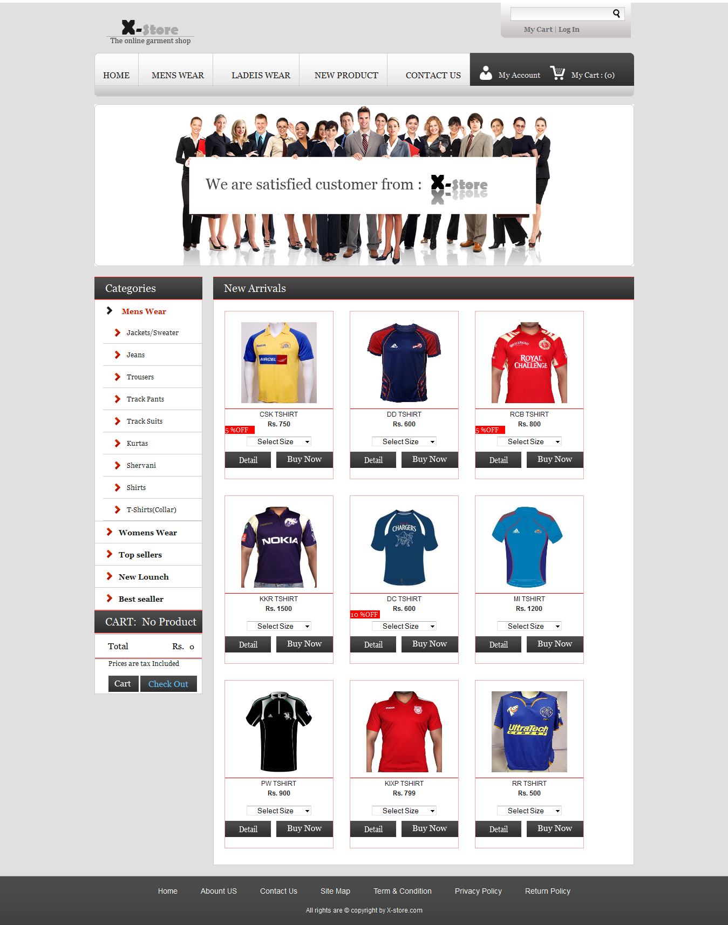

1. **Mens Apperial Jackets/Sweater**

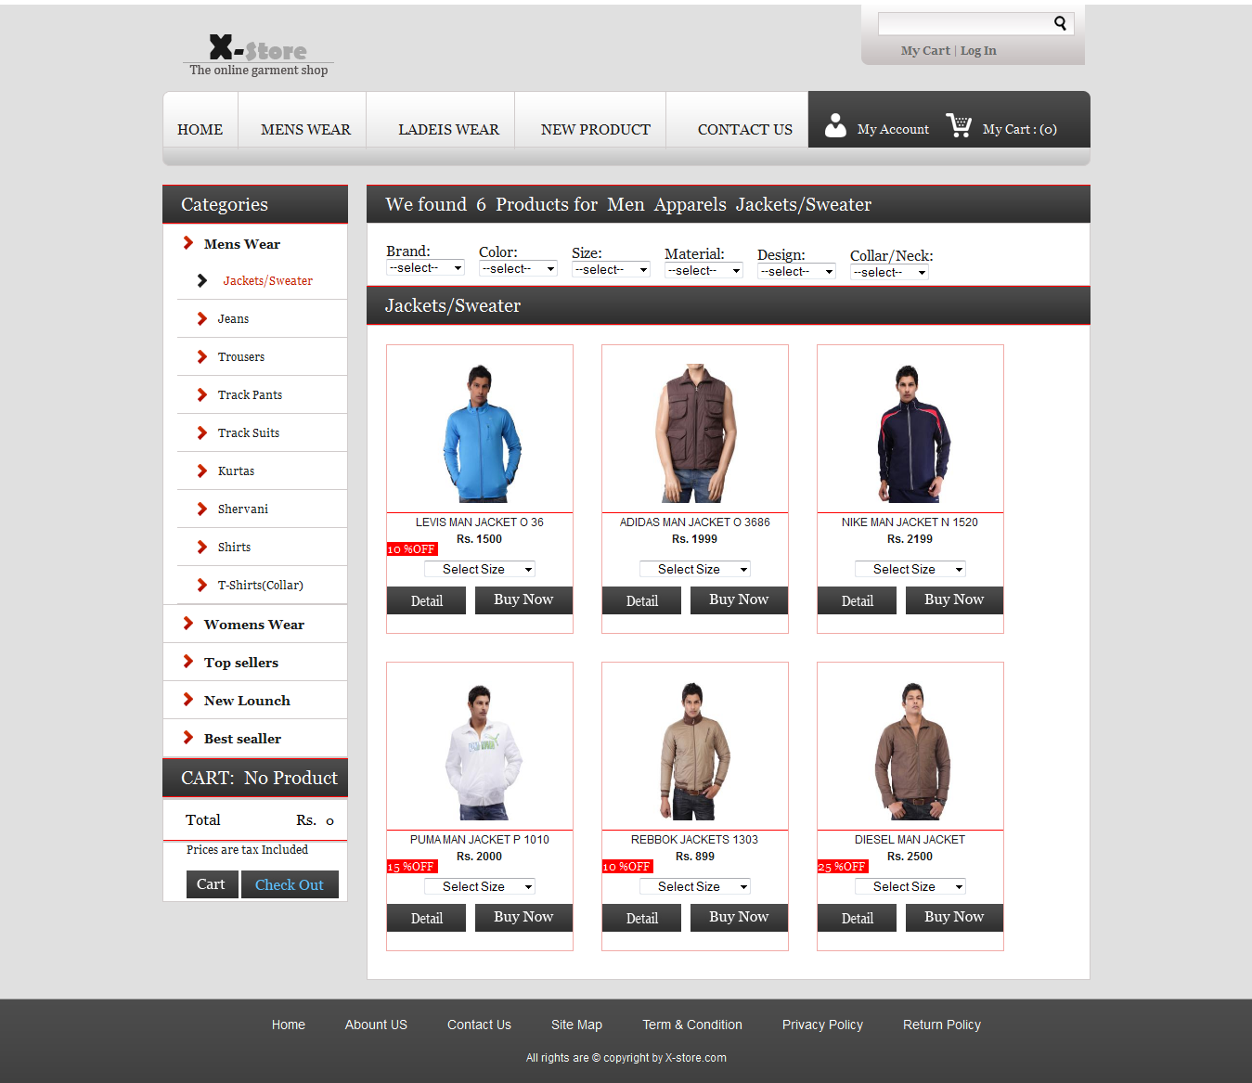

**4. Show Available Size On Hover Of Product Image**

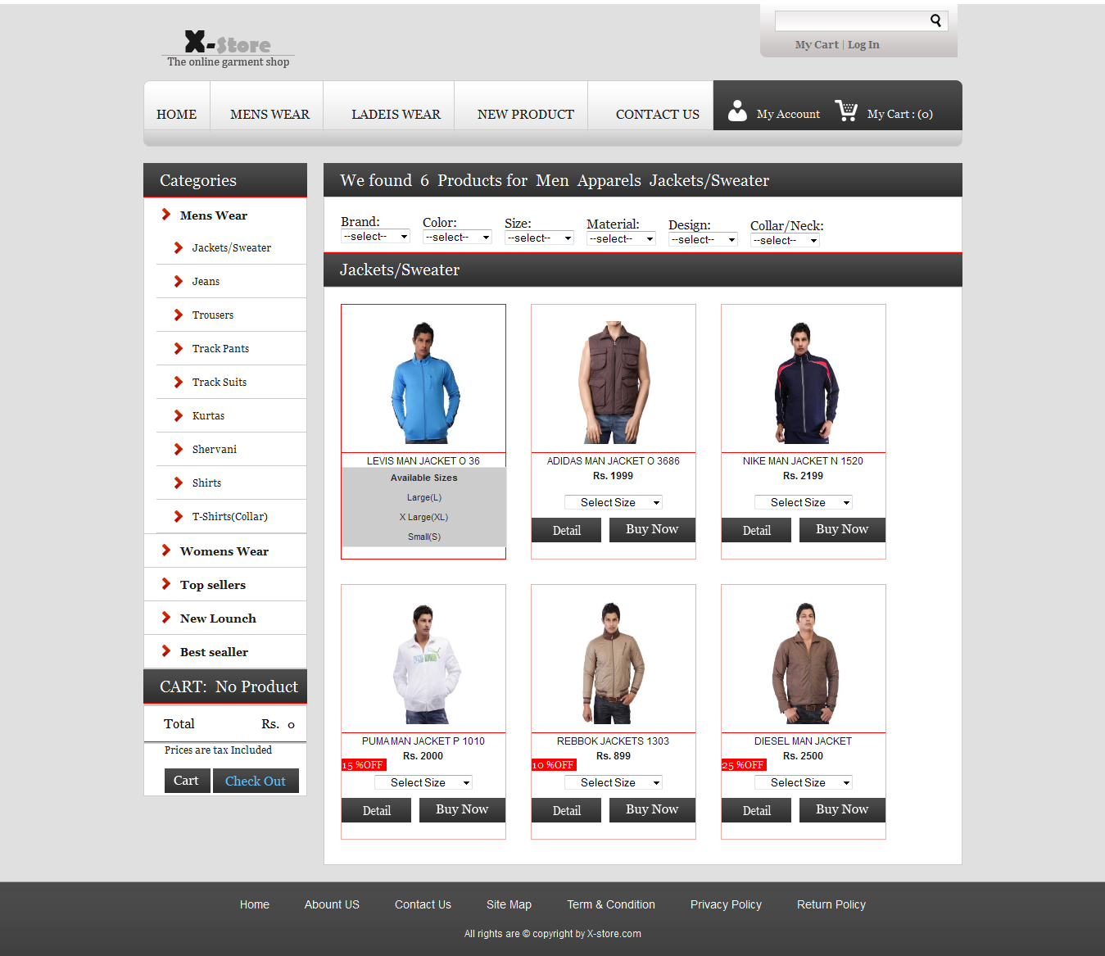

**5. Search Result For Men Apperial Jacket/Sweater For Collars**

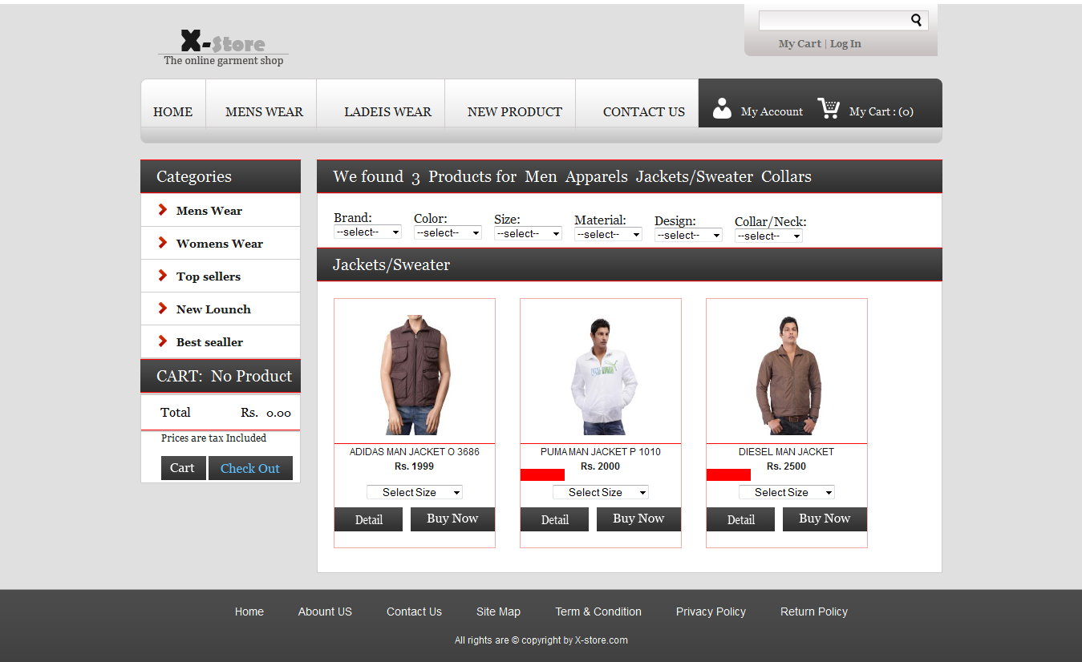

**6. Search Result For Men Apperial Jacket/Sweater For Levis Brand**

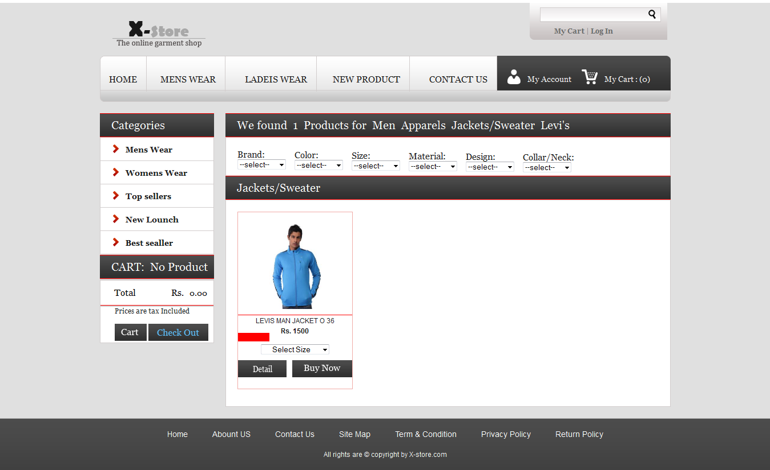

**7. View Product Detail**

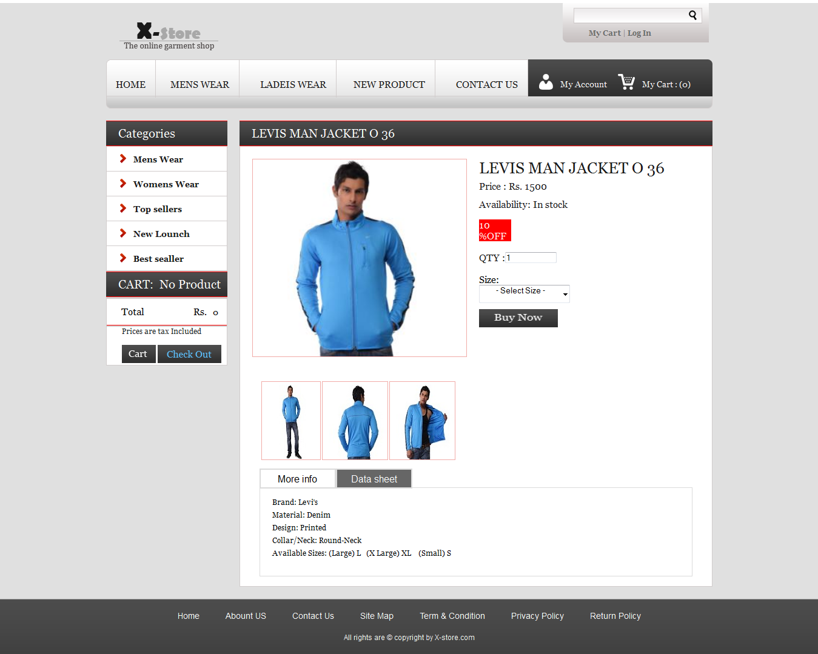

**8. Another View Of Product Image**

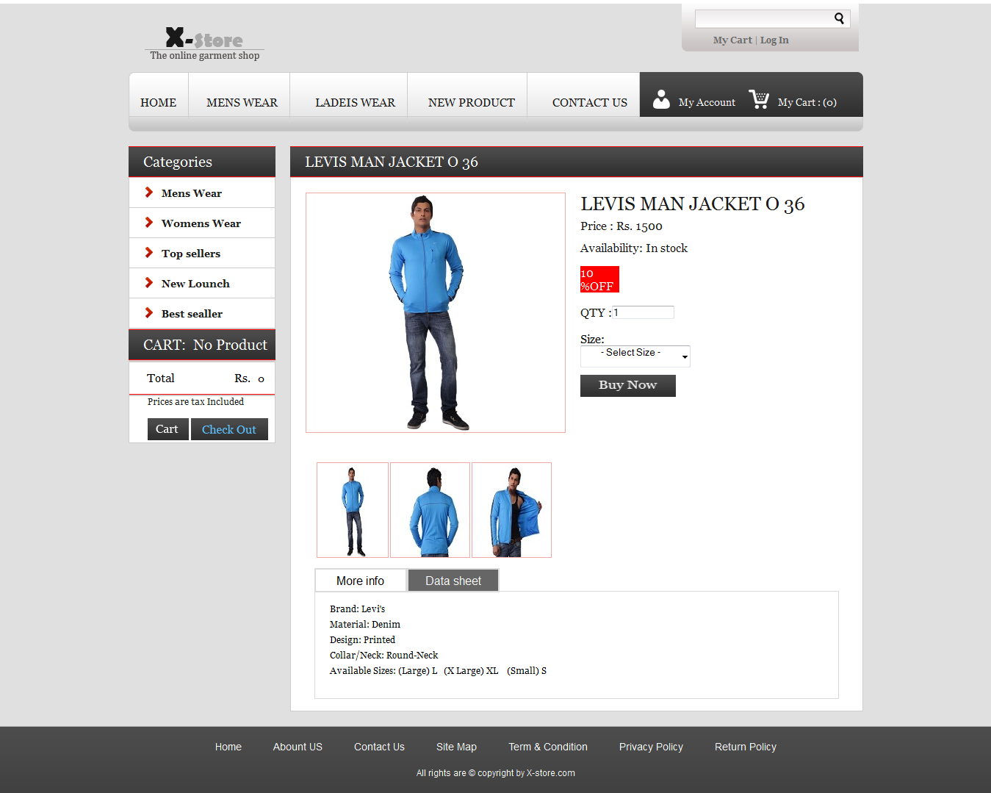

**9. Without Selecting Size User Can’t Add Product To Cart**

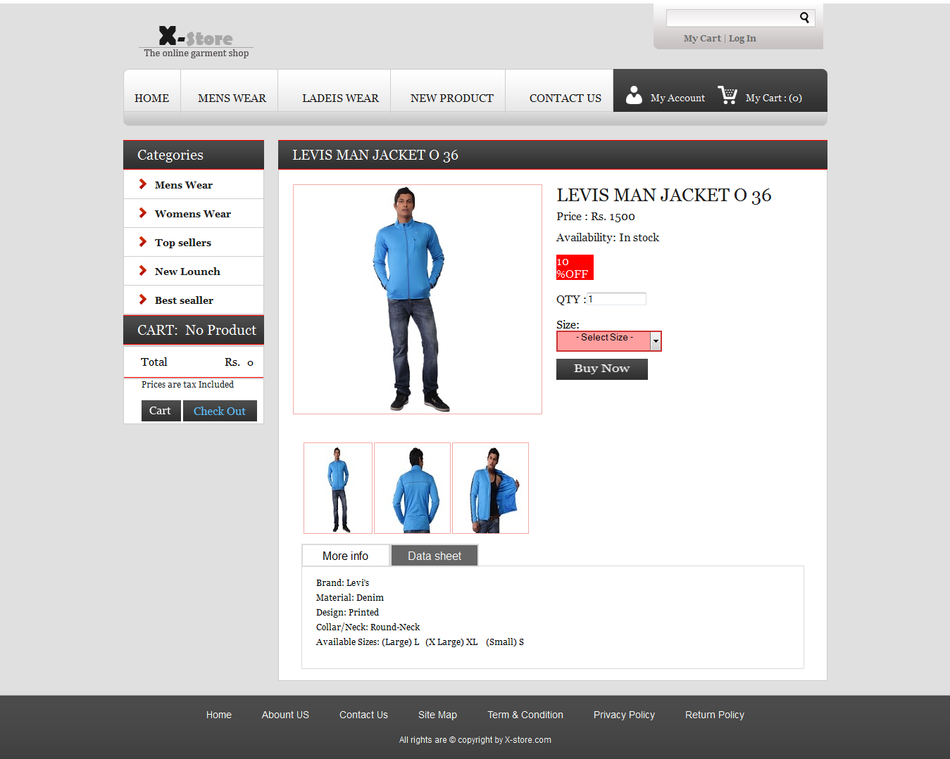

**10. Click To Buy Now And Product Add Into The Cart**

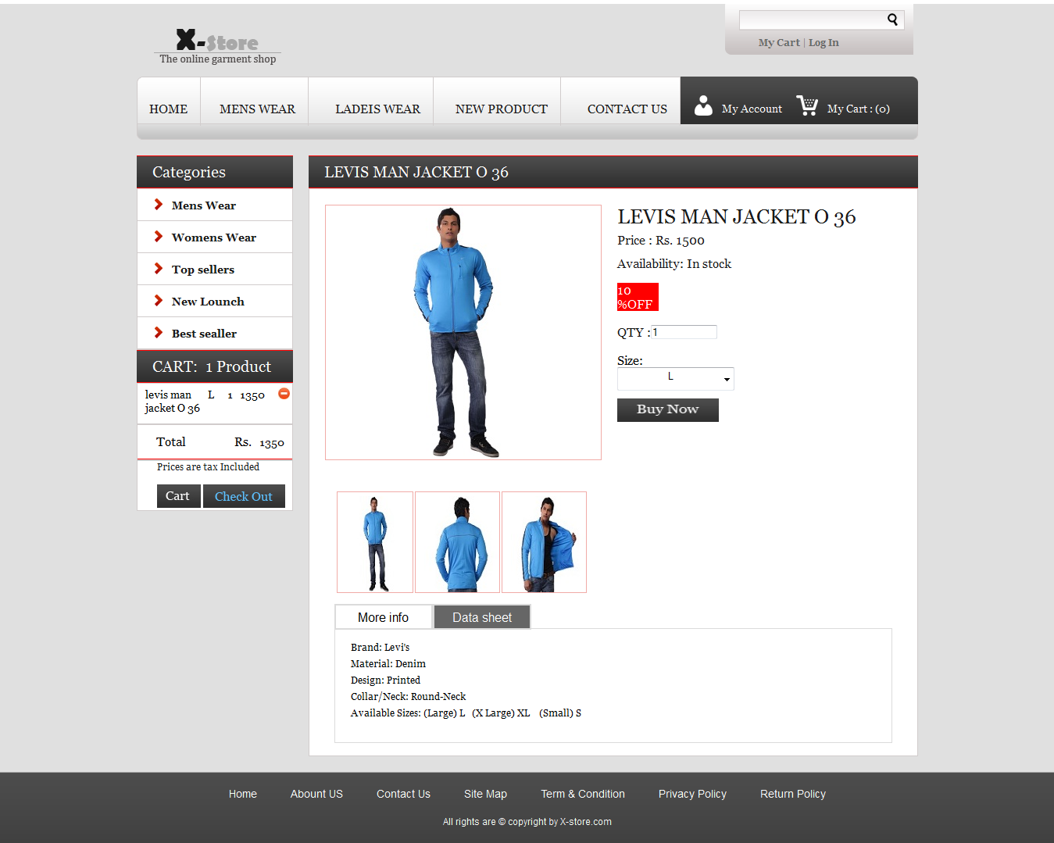

**11. Women’s Wear Subcategory View**

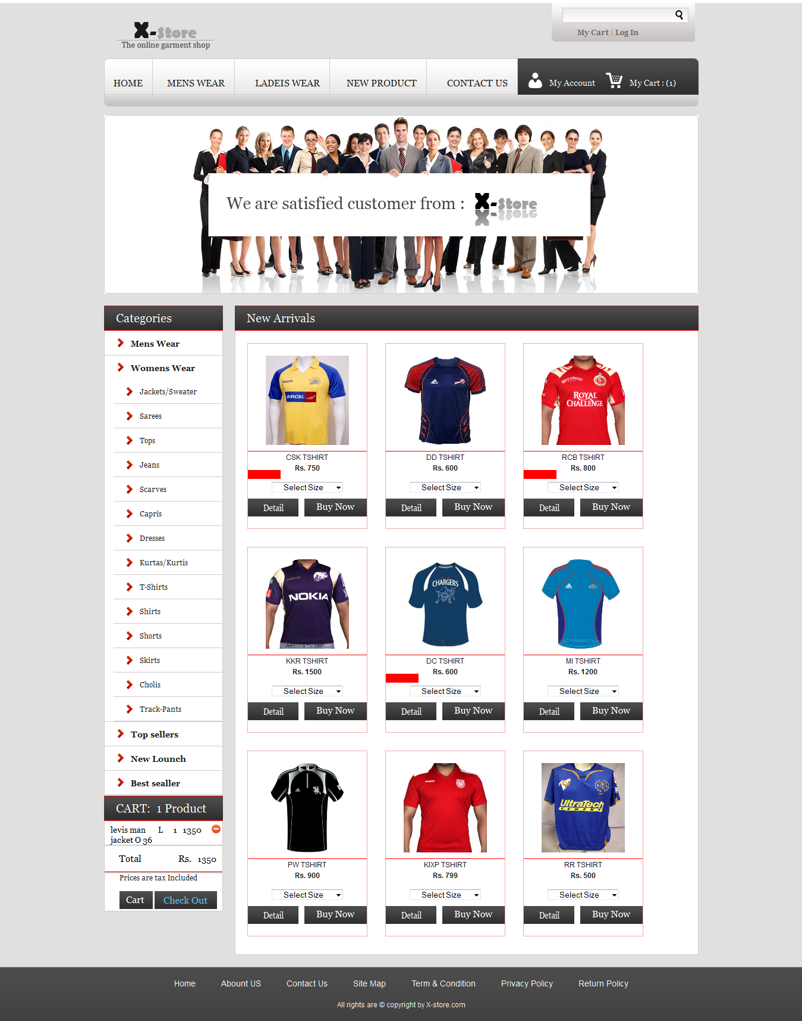

**12. Women’s Apperial Jackets/Sweater**

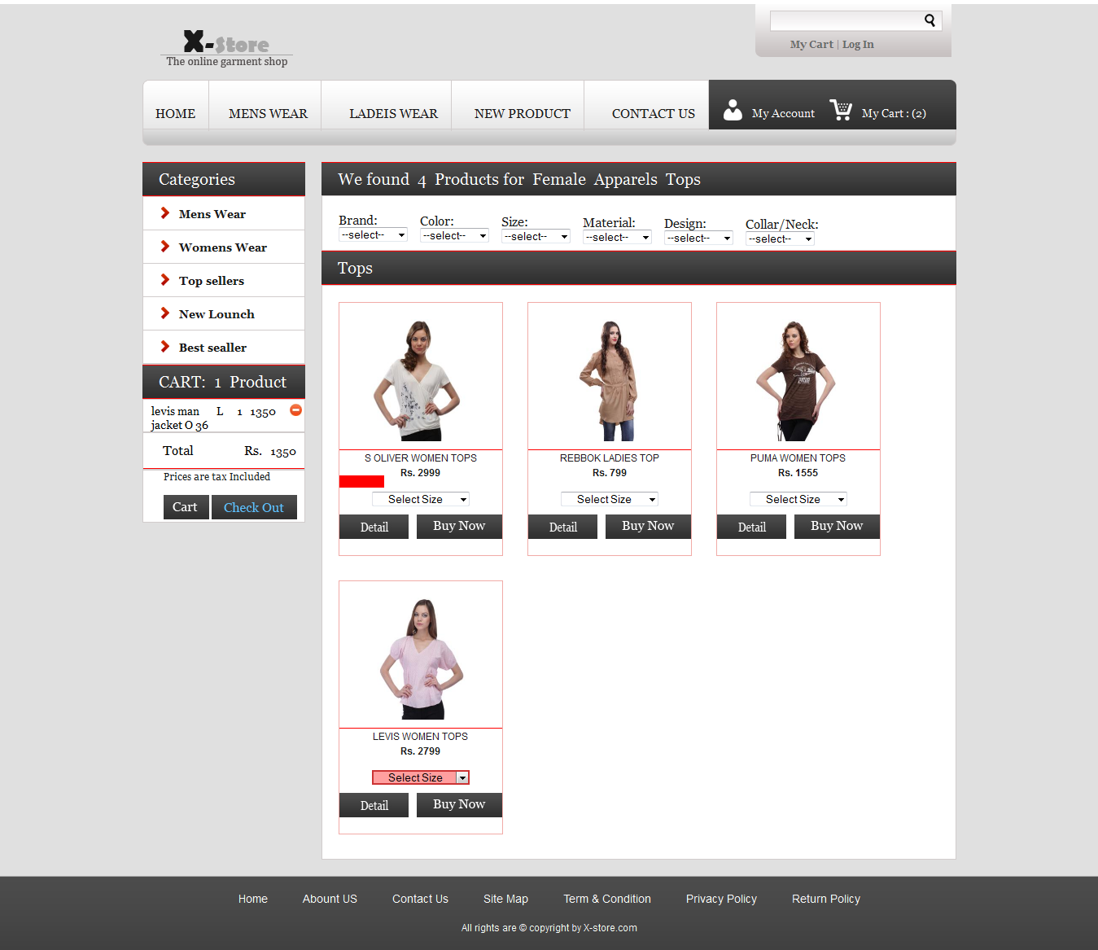

**13. Select Size And Add To Cart From Ladies Top**

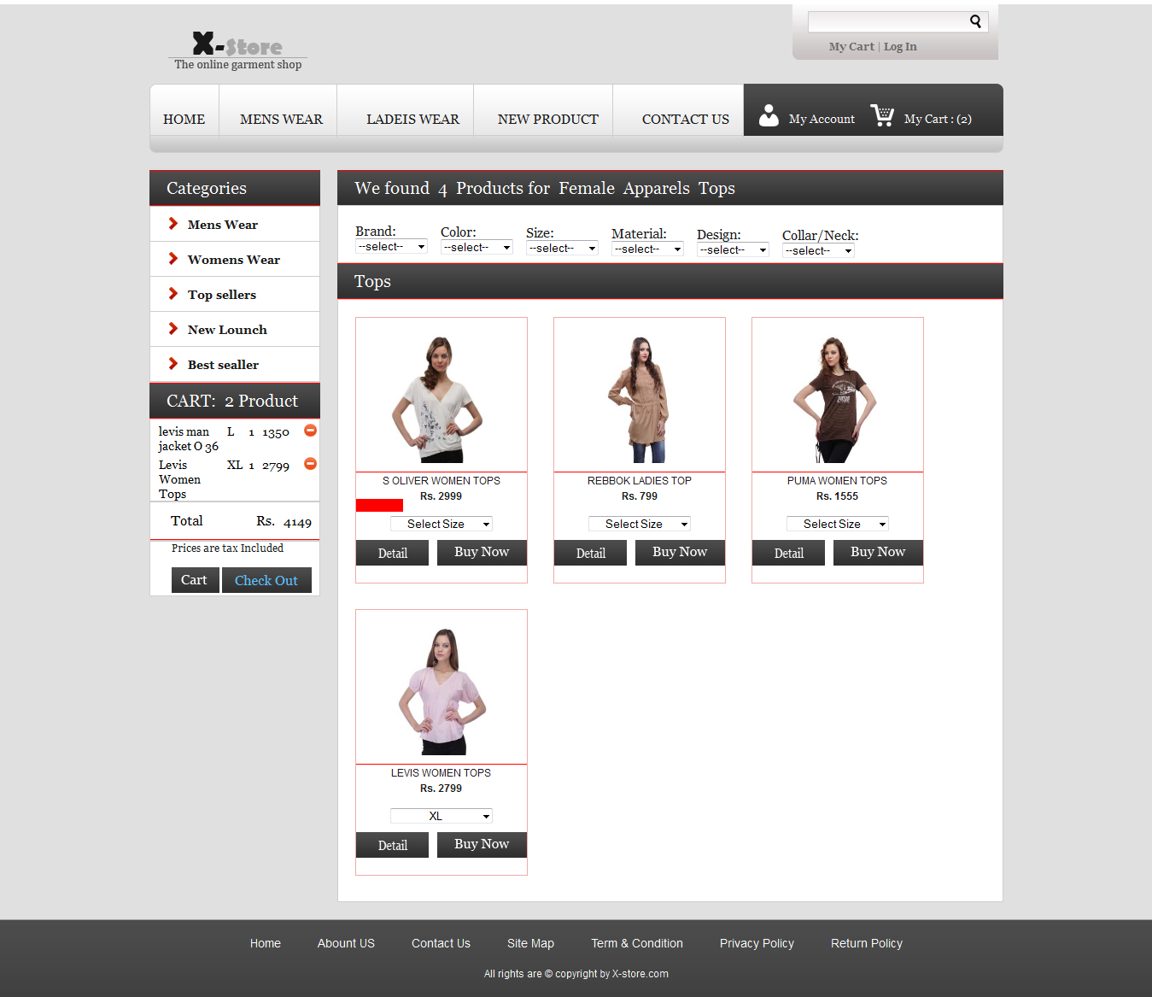

**14. Select Size And Add To Cart From New Arrivals**

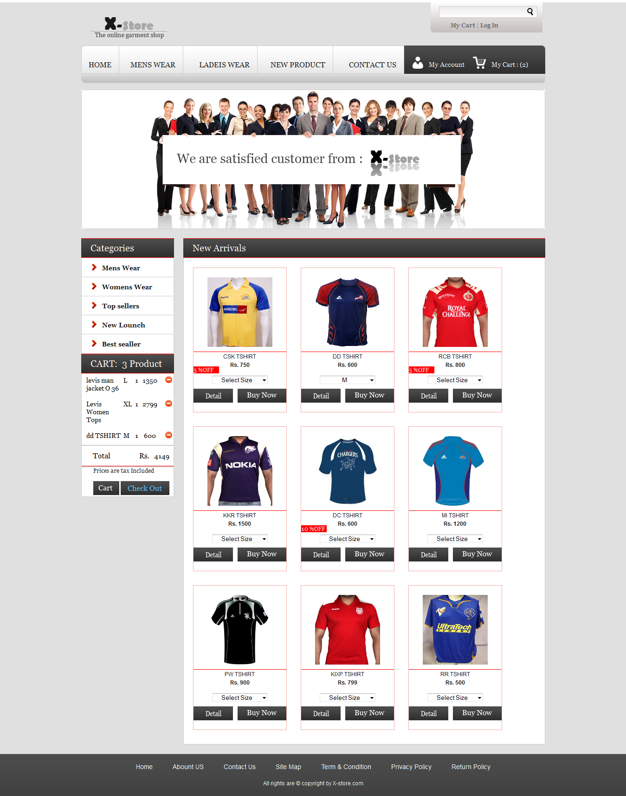

**15. Shopping Cart**

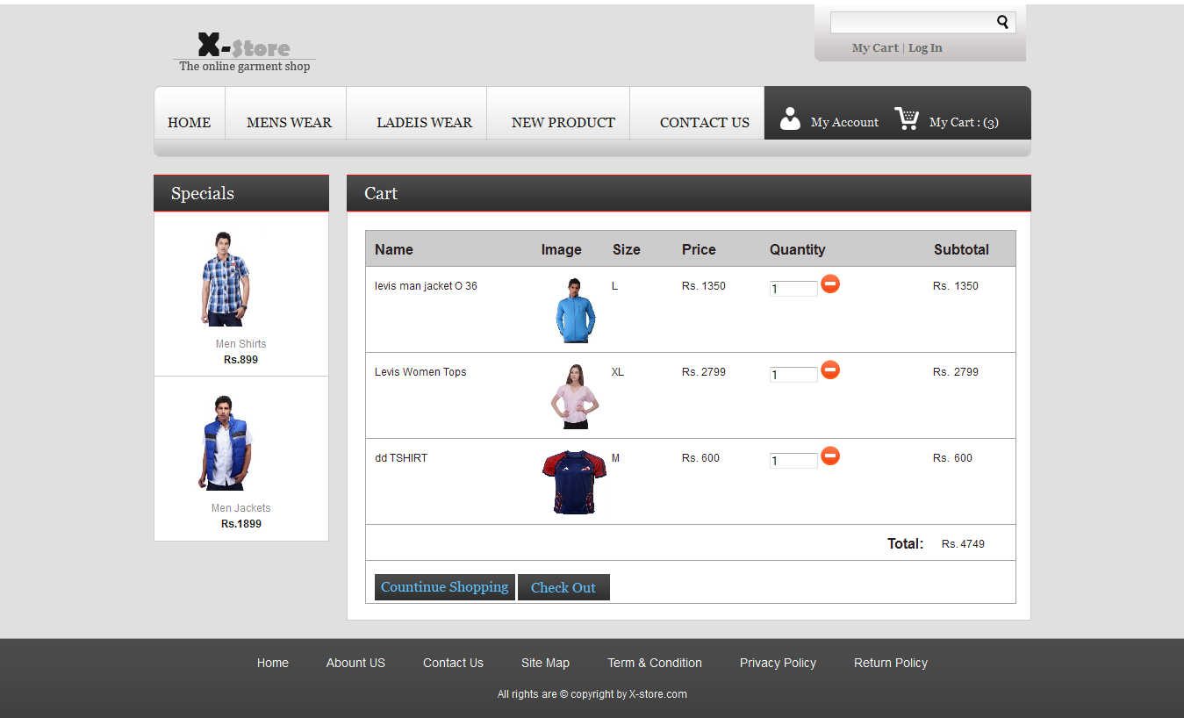

**16. Update Shopping Cart By Just Increase The Quantity**

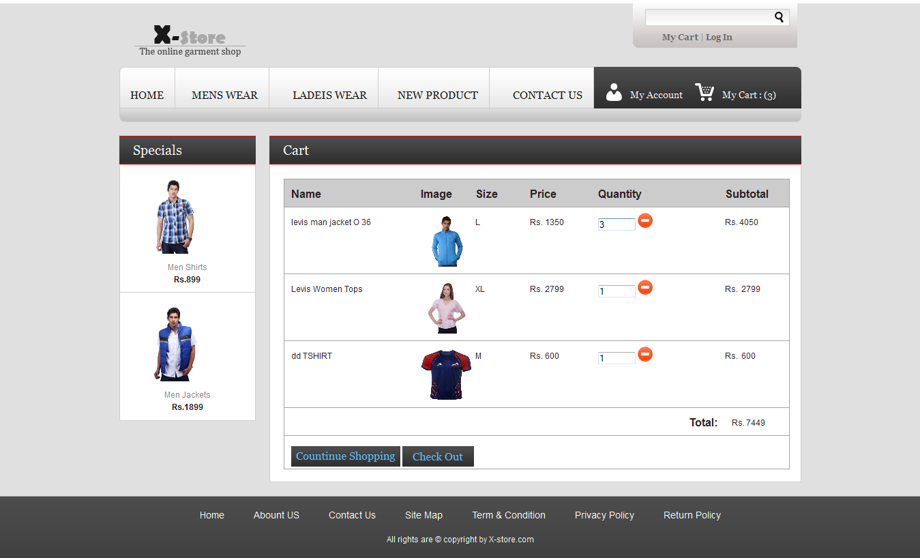

**17. Remove Product From Shopping Cart**

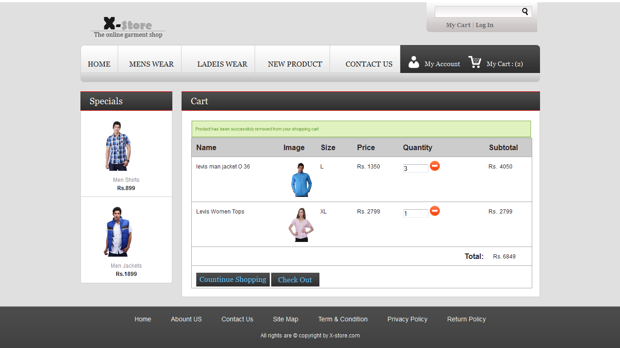

**18. Check Stock Availability and If It Out Of Stock Then Display Error Message**

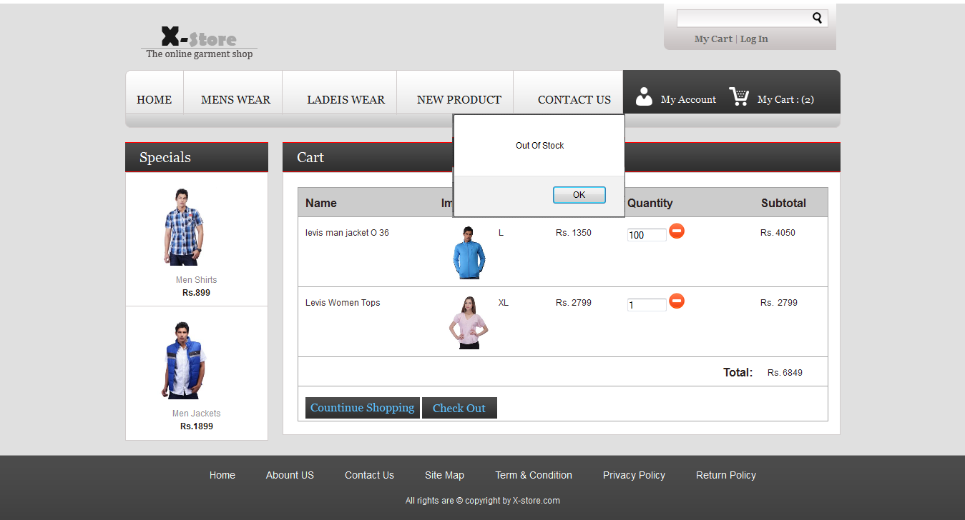

**19. Out Of Stock Then Display Error Message And Assign Old Value To Quantity**

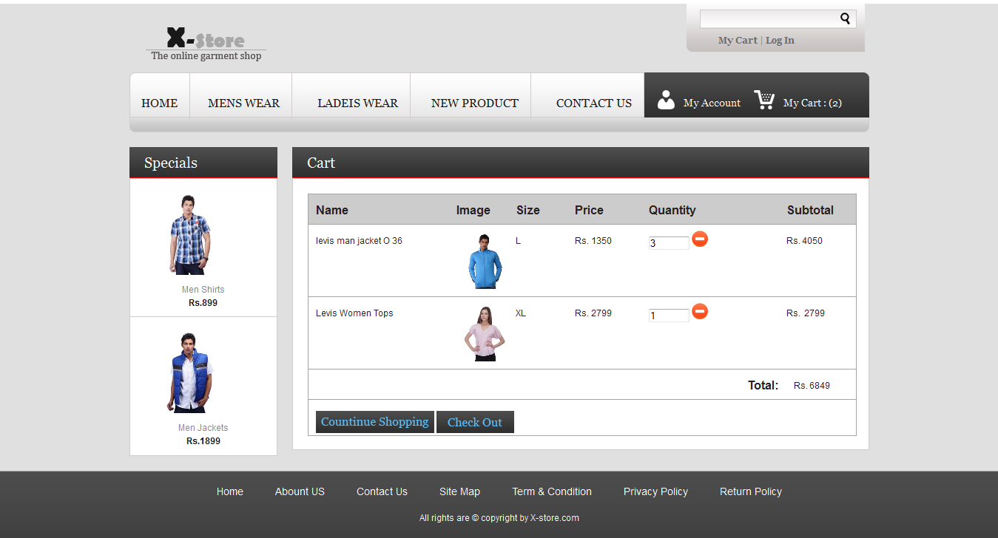

**20. if User Is Already Registered Then Login Here**

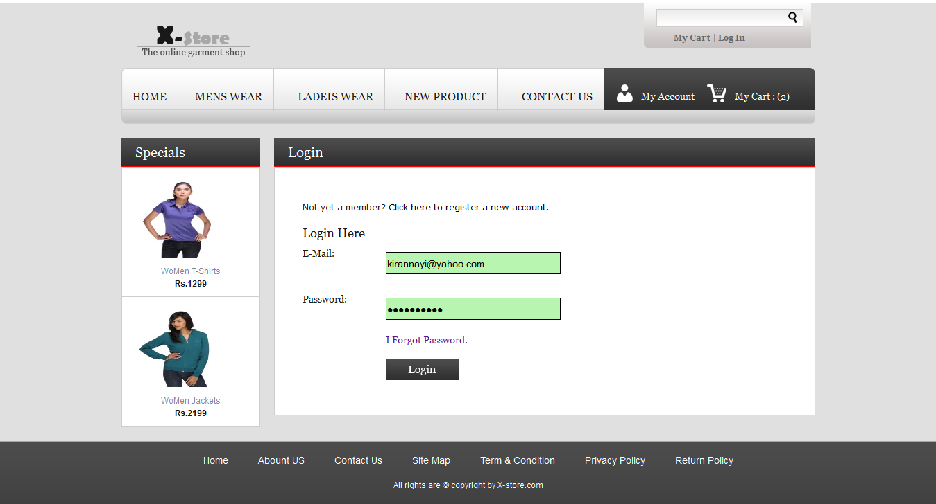

**21. Invalid Login**

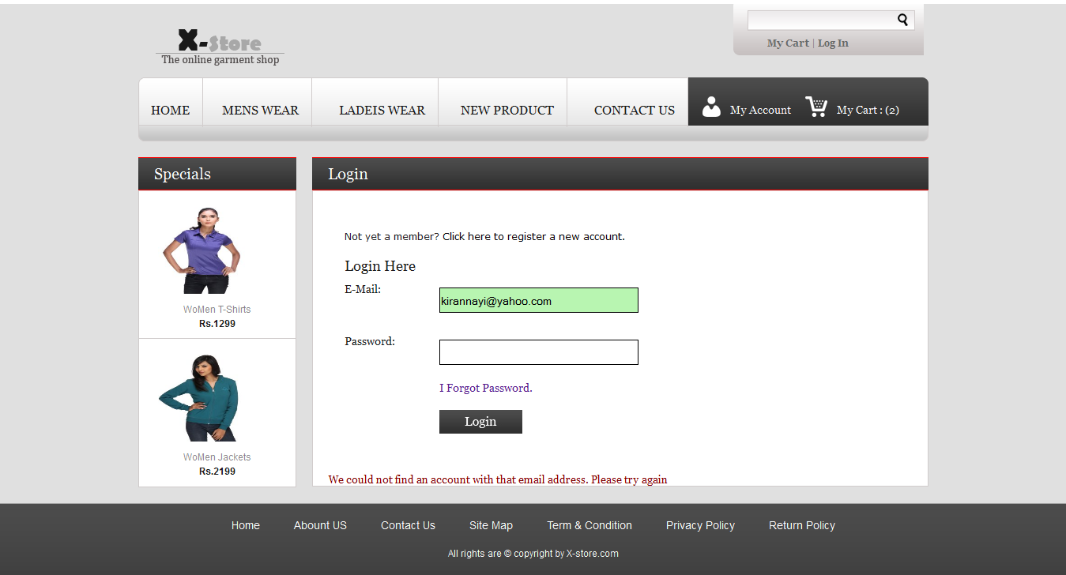

**22. Successful Login Then Redirect To SetExpressCheckOut Page**

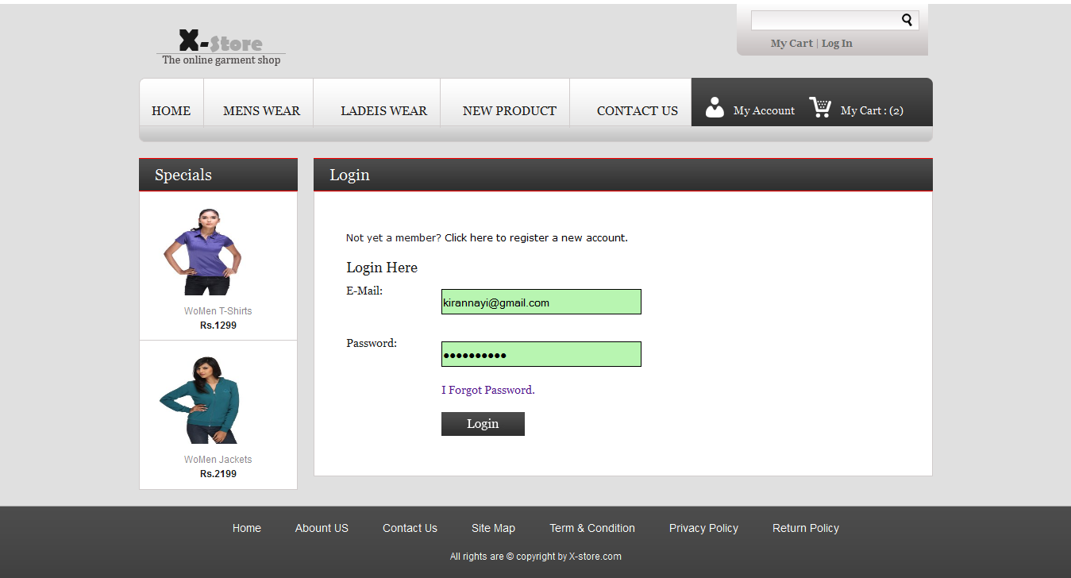

**23. SetExpressCheckOut Page Add or Edit Billing And Shipping Address here**

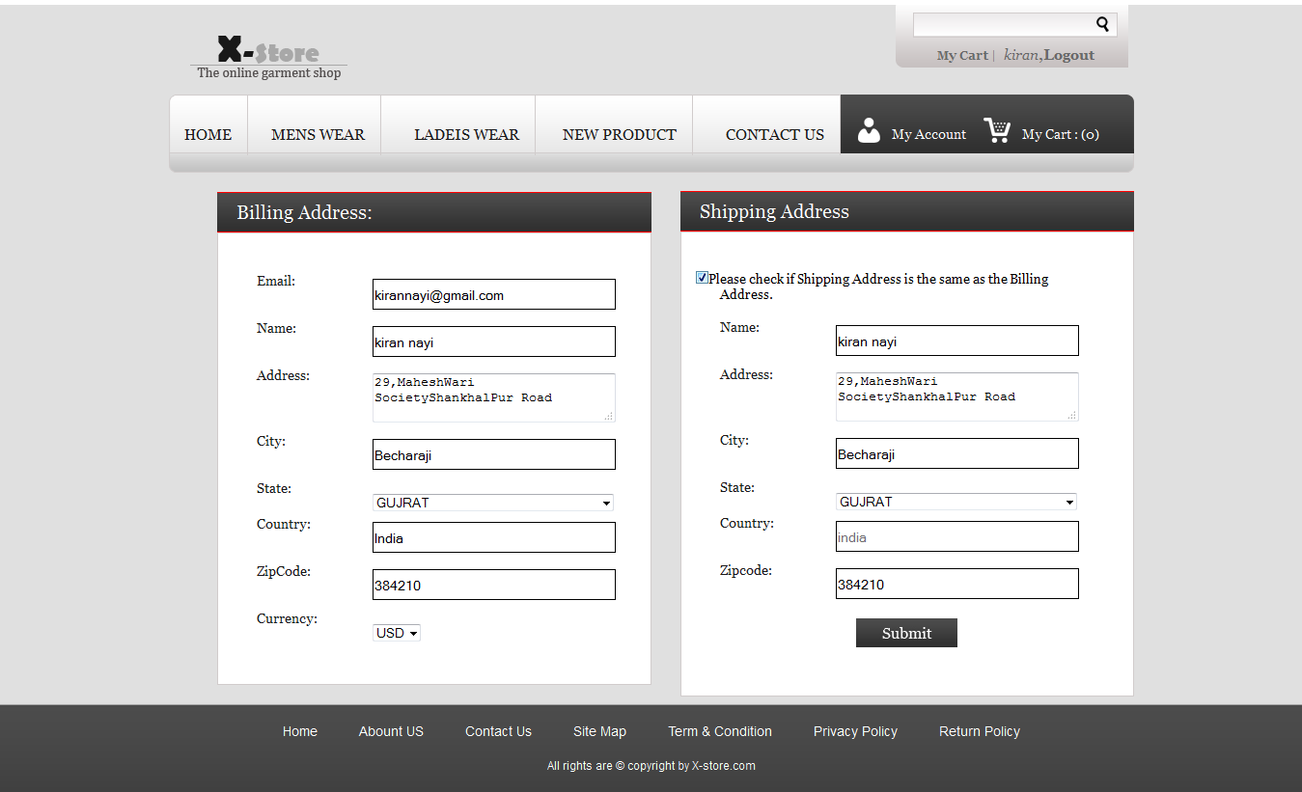

**24. New Member Registration Page with Validation**

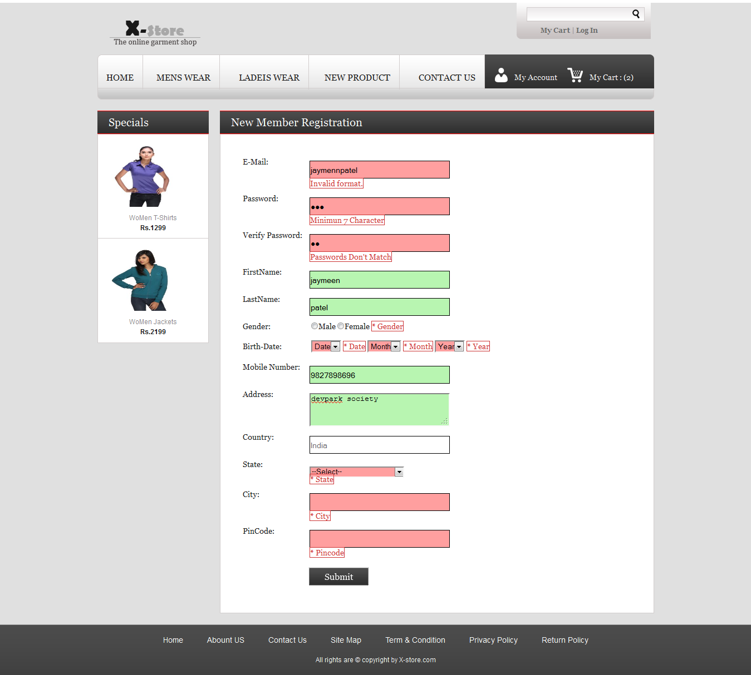

**25. New Member Registration Page with Appropriate Data**

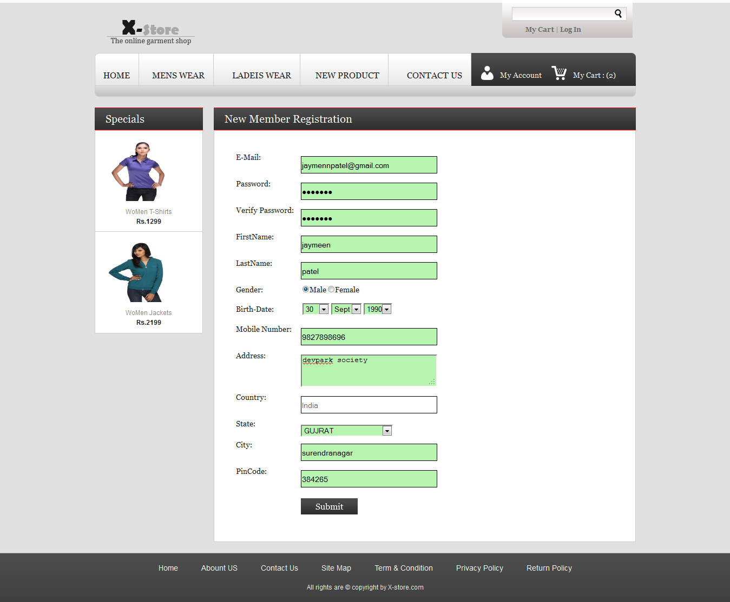

**26. Billing And Shipping Detail Of User**

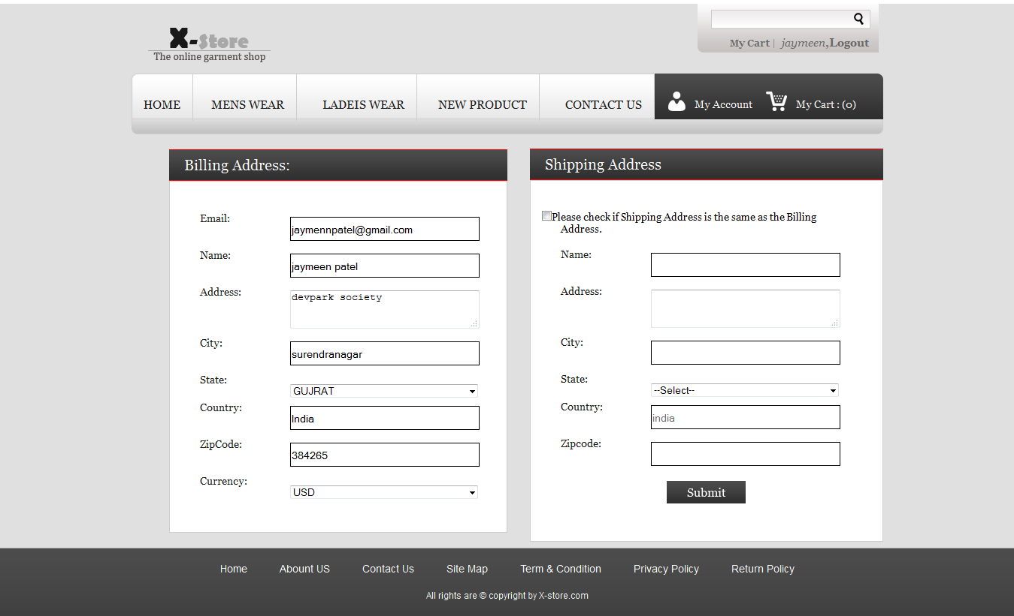

**27. If User Want Shipping Address As Billing Address Then Click On Checkbox**

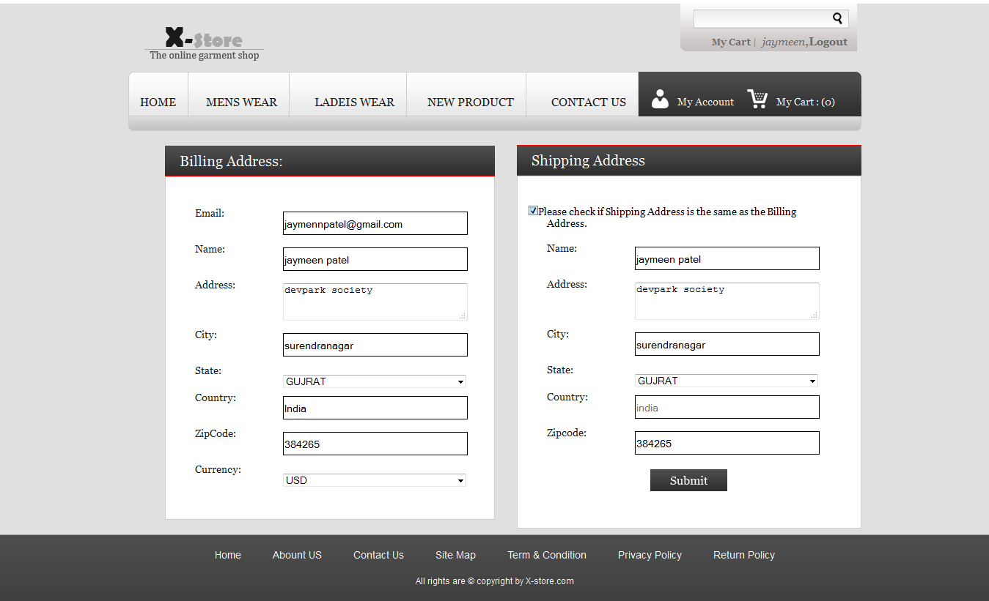

**28. PayPal Home**

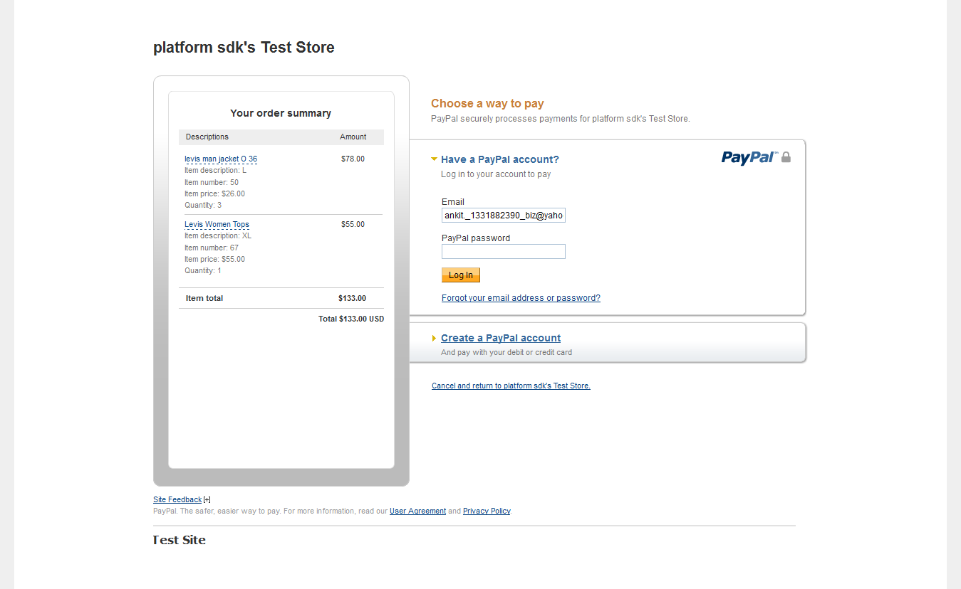

**29. Login With Valid Username And Password**

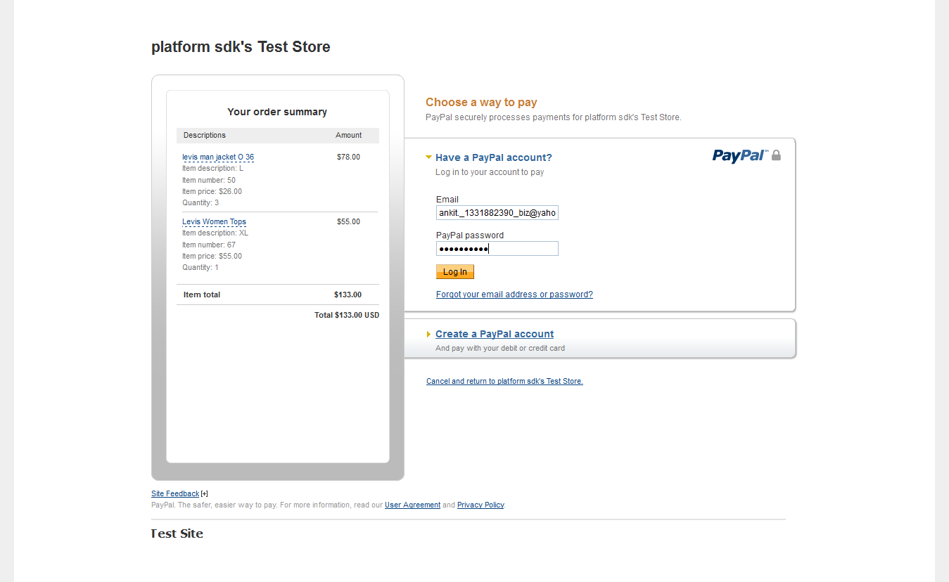

**29. Page With Products Detail Click On Continue For Payment**

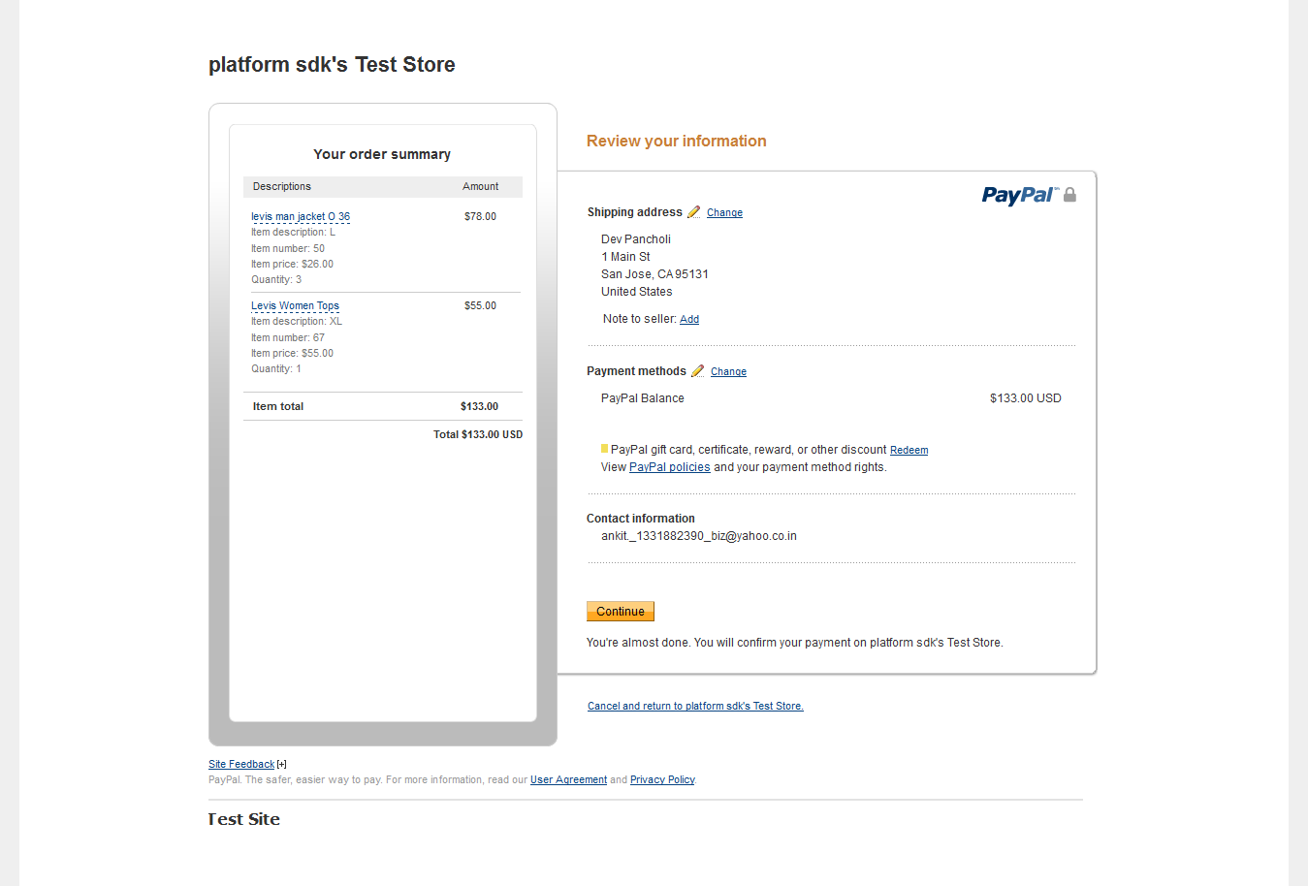

**30. Page With Order Detail Click On Pay To Complete The Transaction**

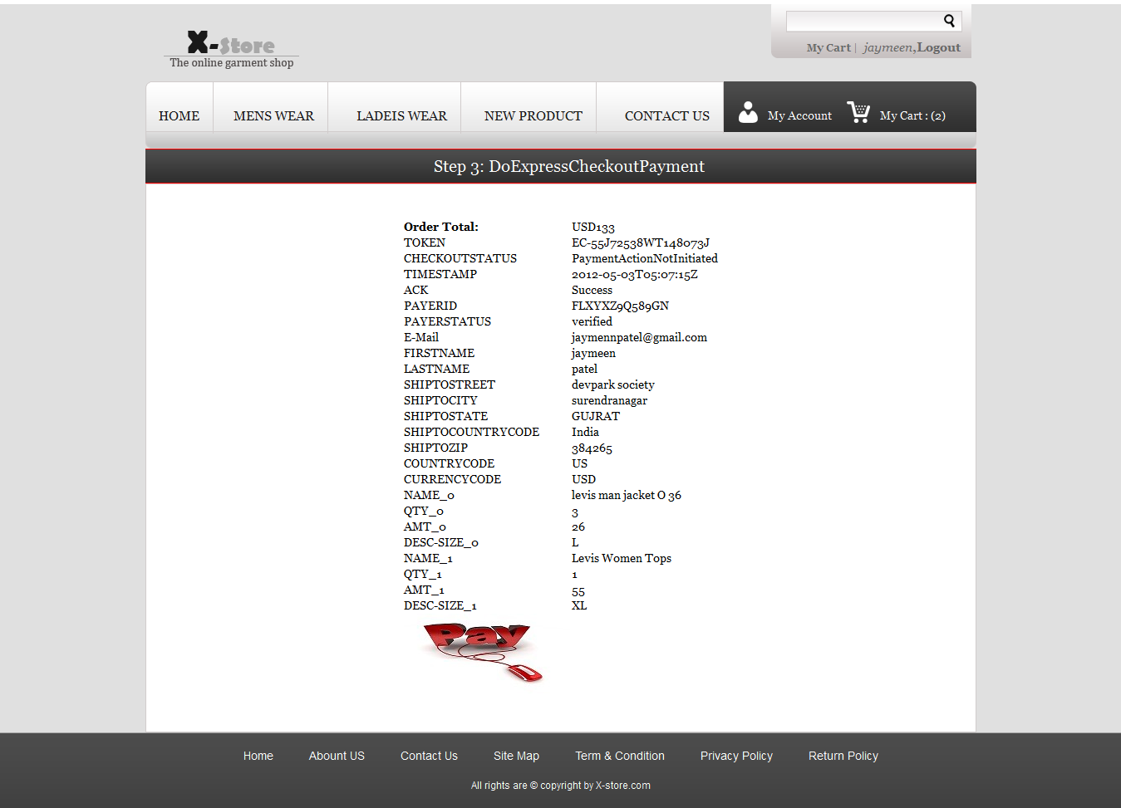

**31. After Click on Pay PayPal Return User to Merchant’s Site with Some Useful Data**

**As Below**

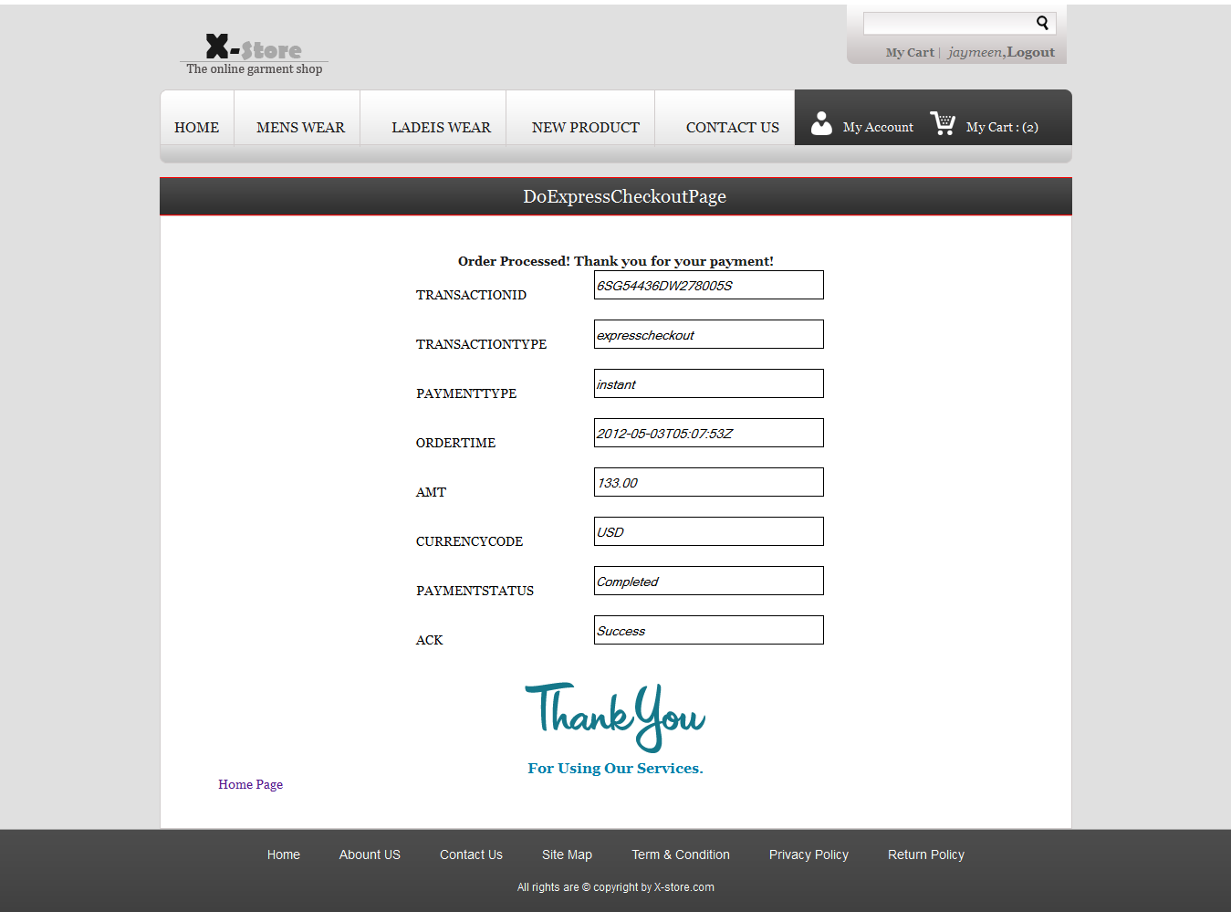

**32. Searching Facility With Enter Any Keyword**

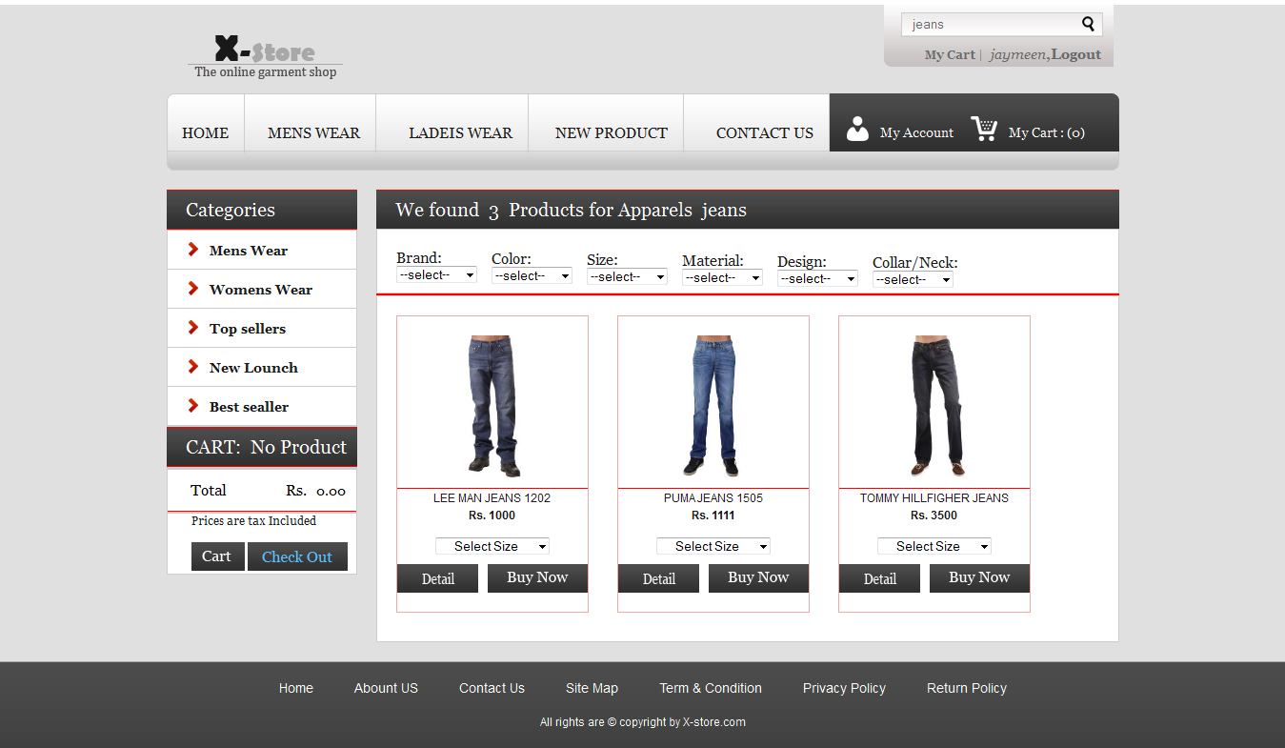

**33. Sitemap for Website**

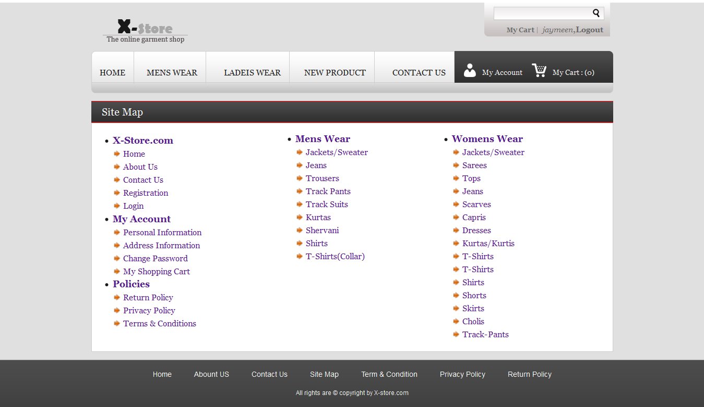

**34. If User Click On Mens Wear In Menu Then Display All Product For Men Apperial**

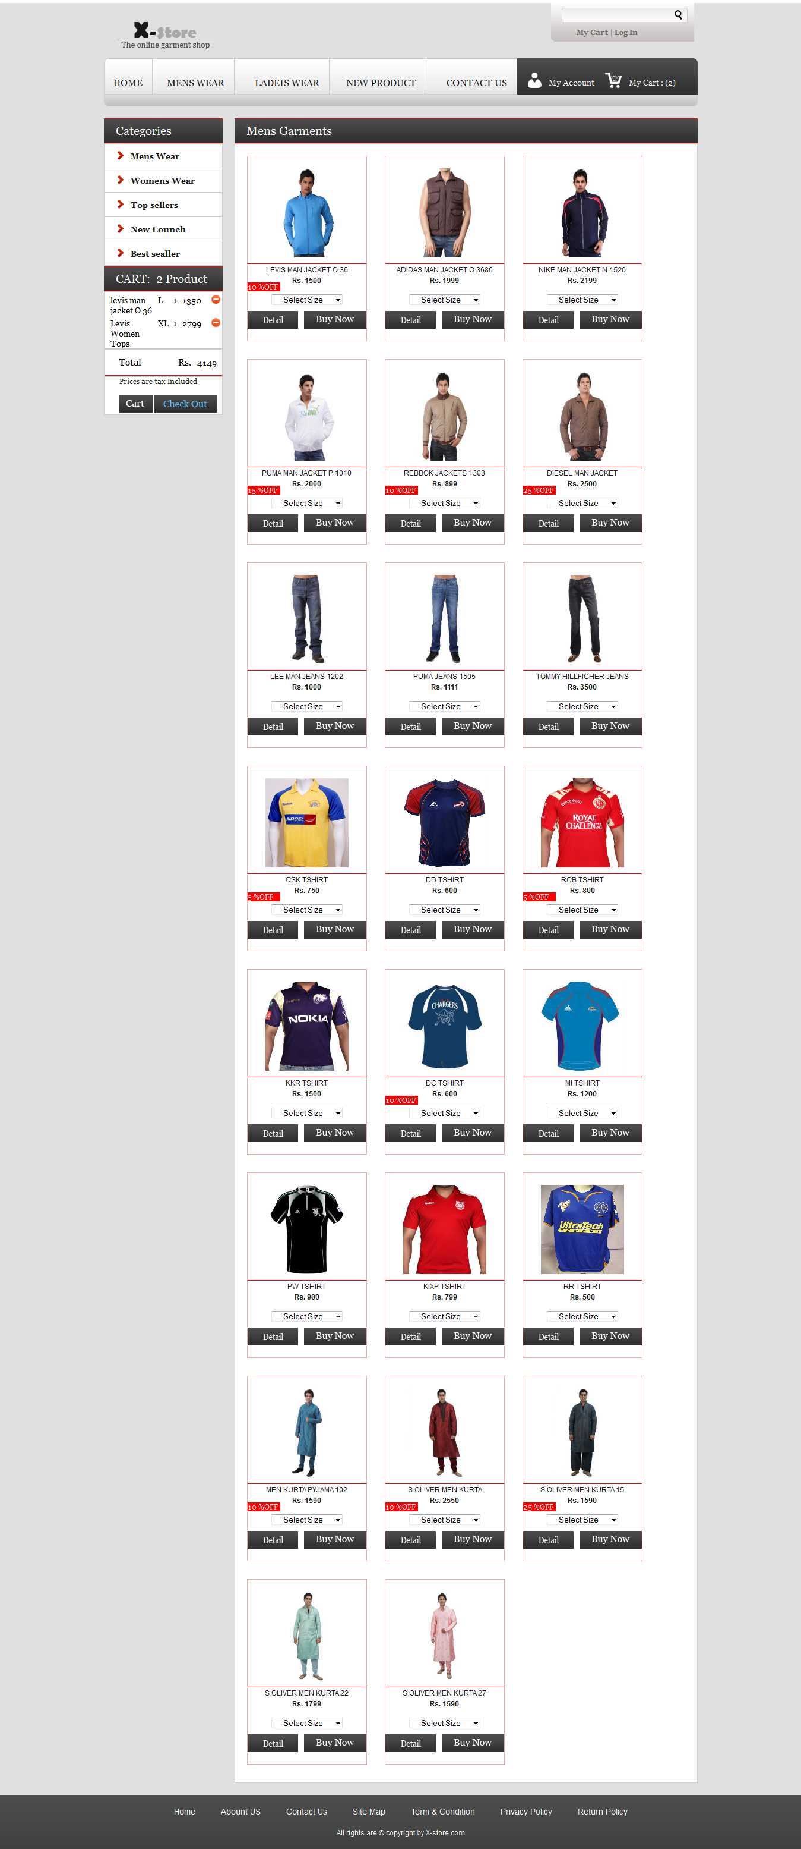

**35. If User Click On WoMens Wear In Menu Then Display All Product For WoMen Apperial**

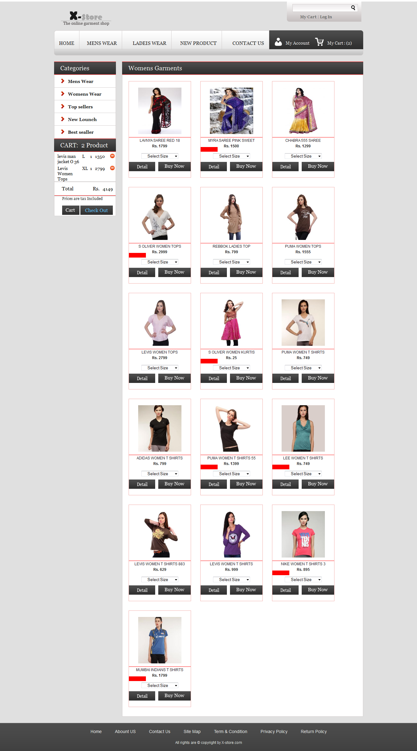

**36. Admin Side Invalid Login Area**

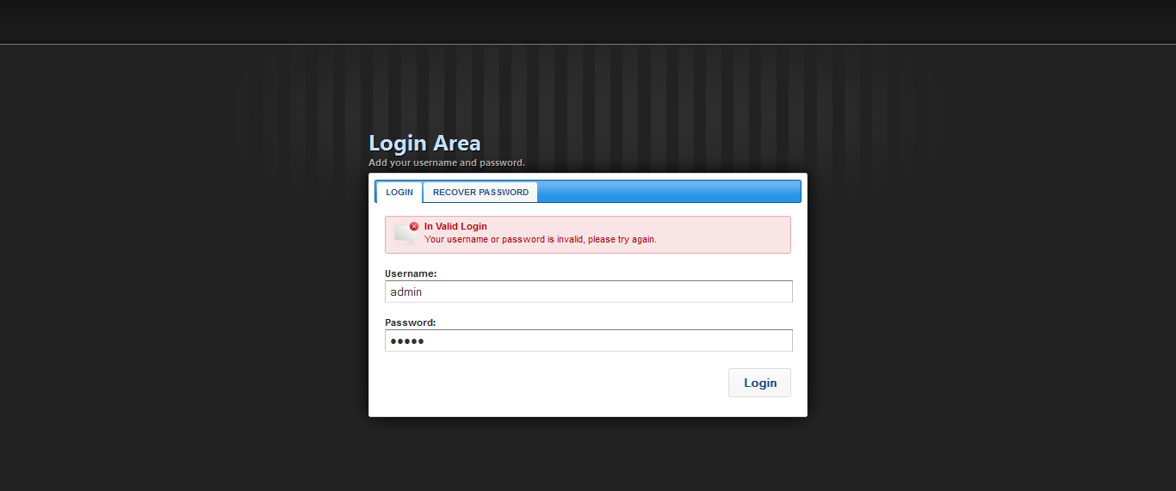

**37. Admin Side Login**

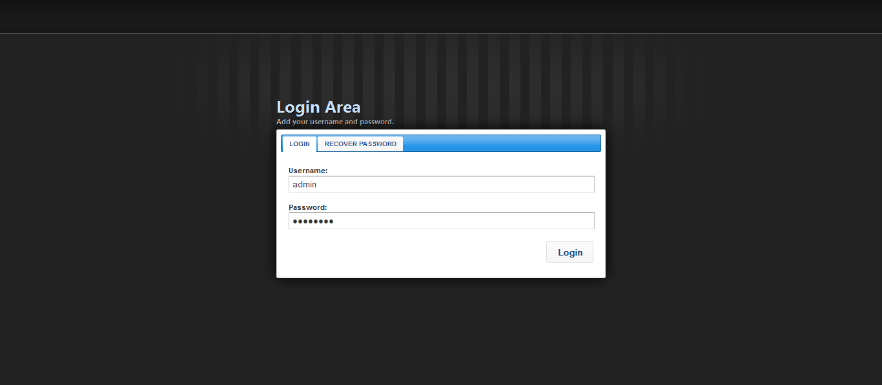

**38. Home Page**

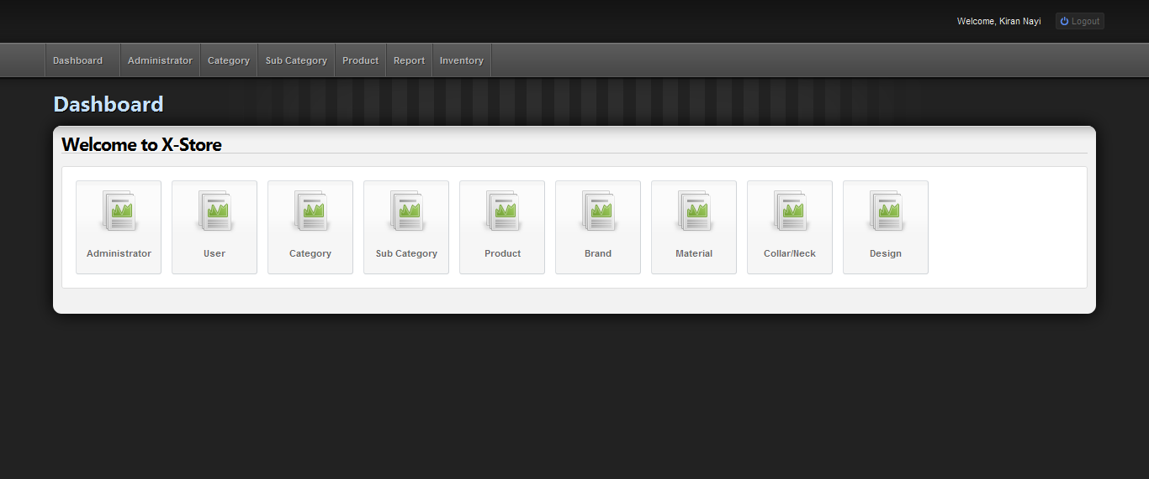

**39. Admin List**

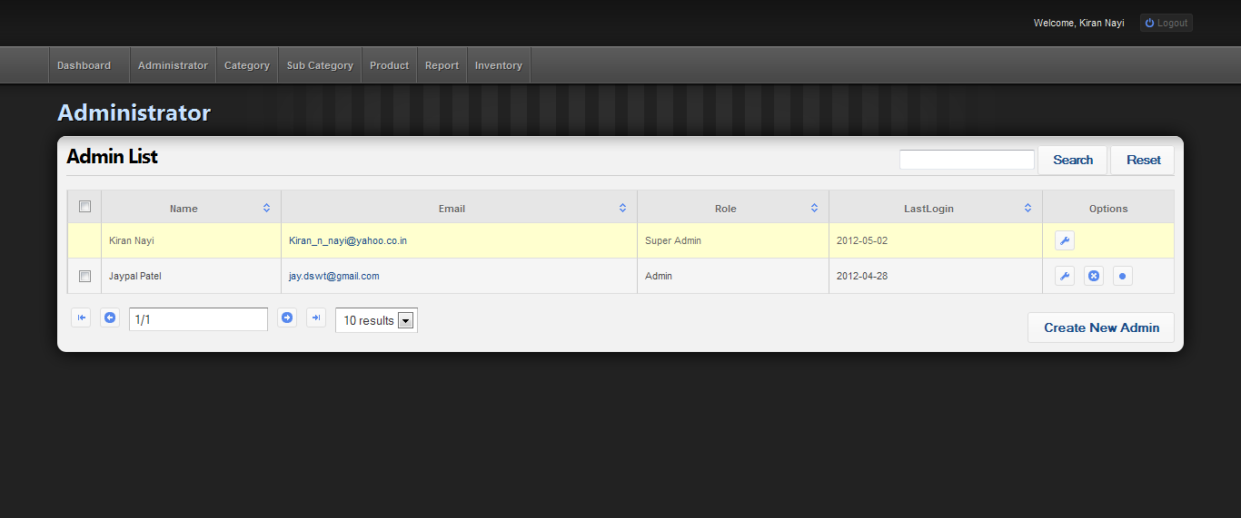

**40. Active the Sub Admin By Super Admin**

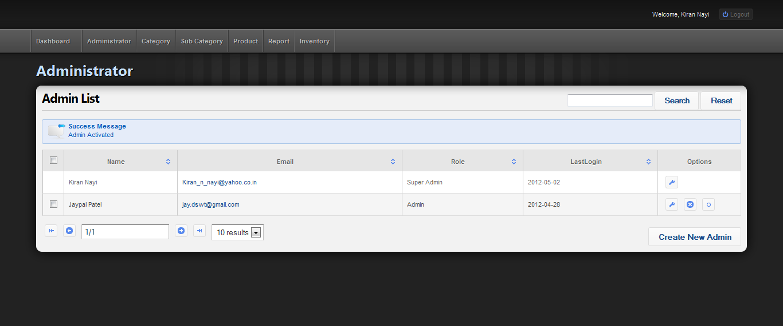

**41. User List**

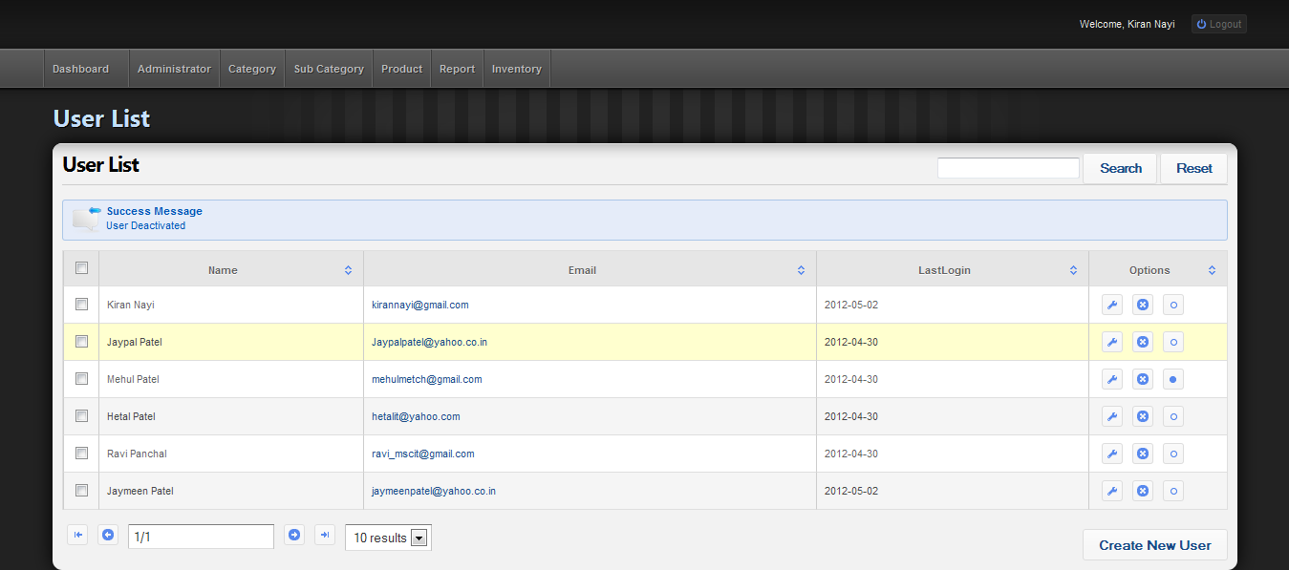

**42. User Delete By Admin**

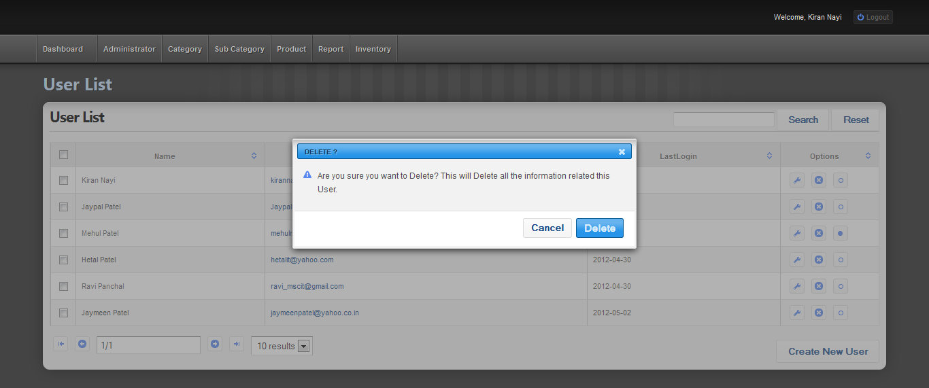

**43. User Deleted Successfully**

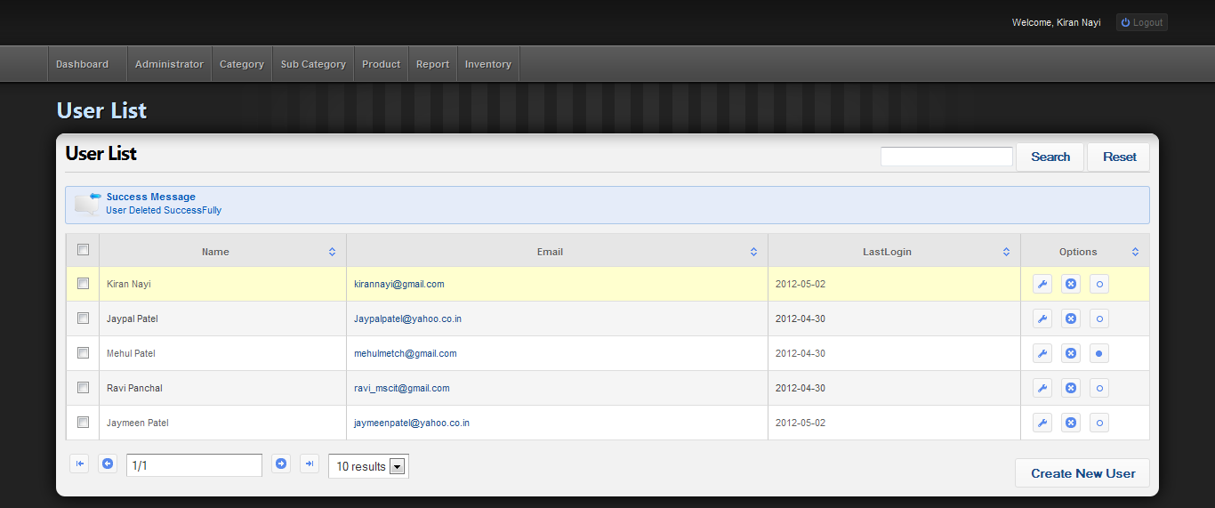

**43. Category List**

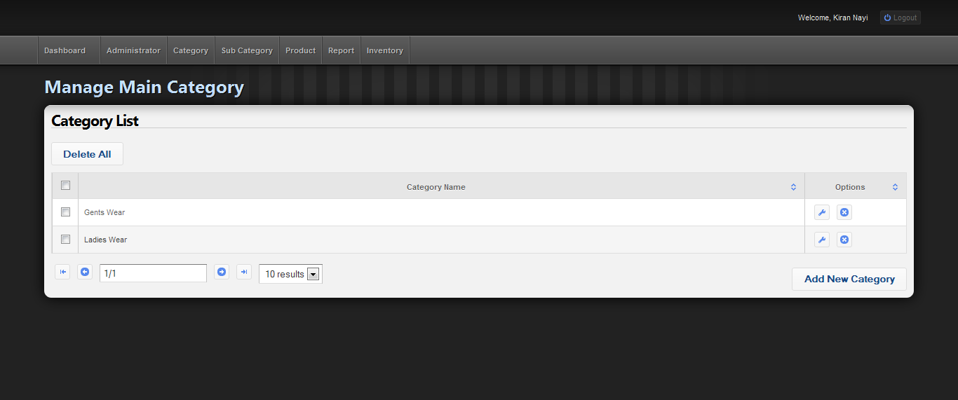

**44. Add New Category**

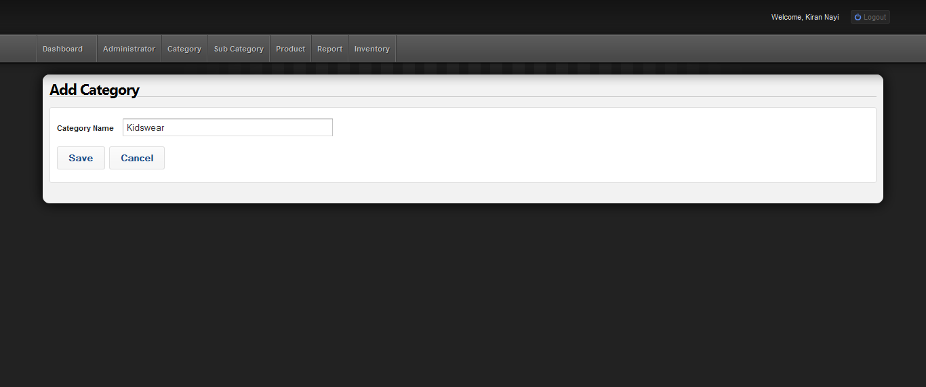

**45. New Category Added Successfully**

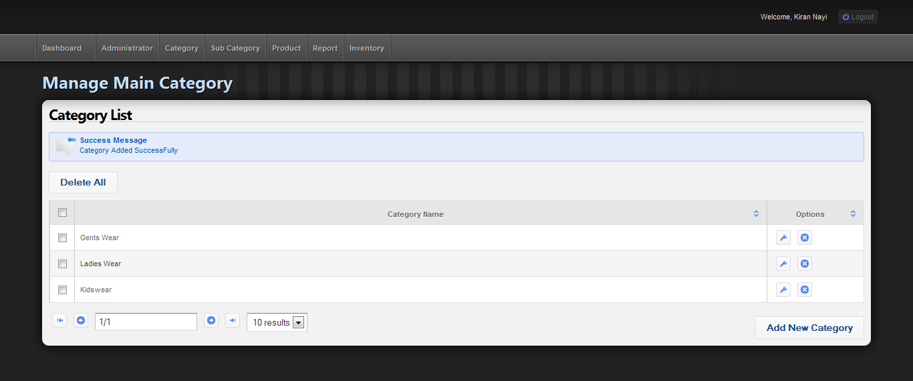

**46. Delete Category From List**

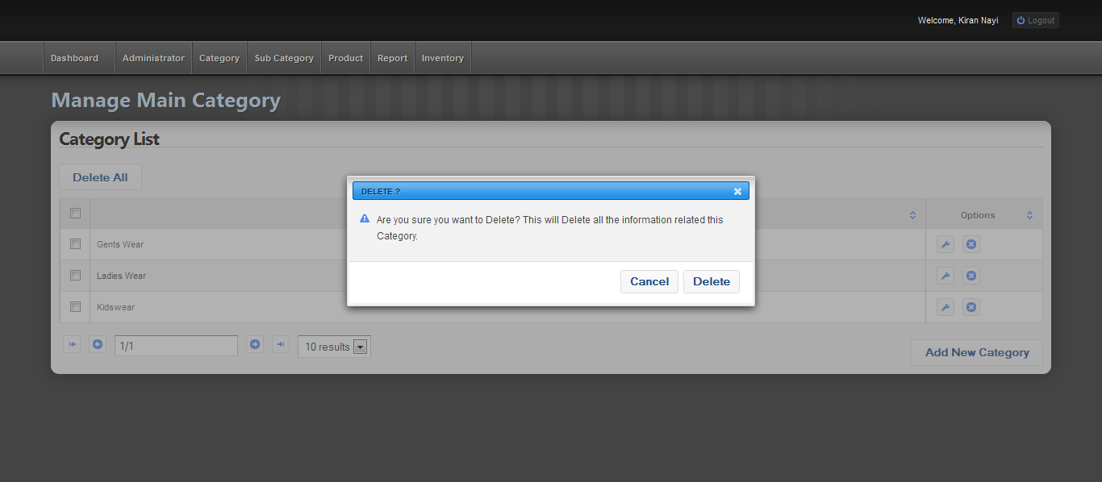

**46. Category Deleted Successfully**

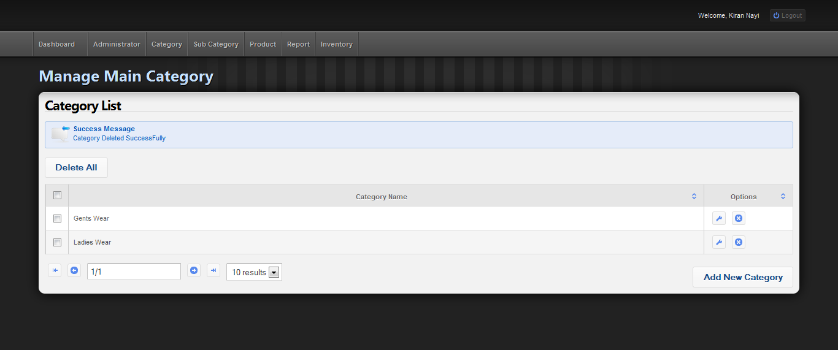

**47. Product List**

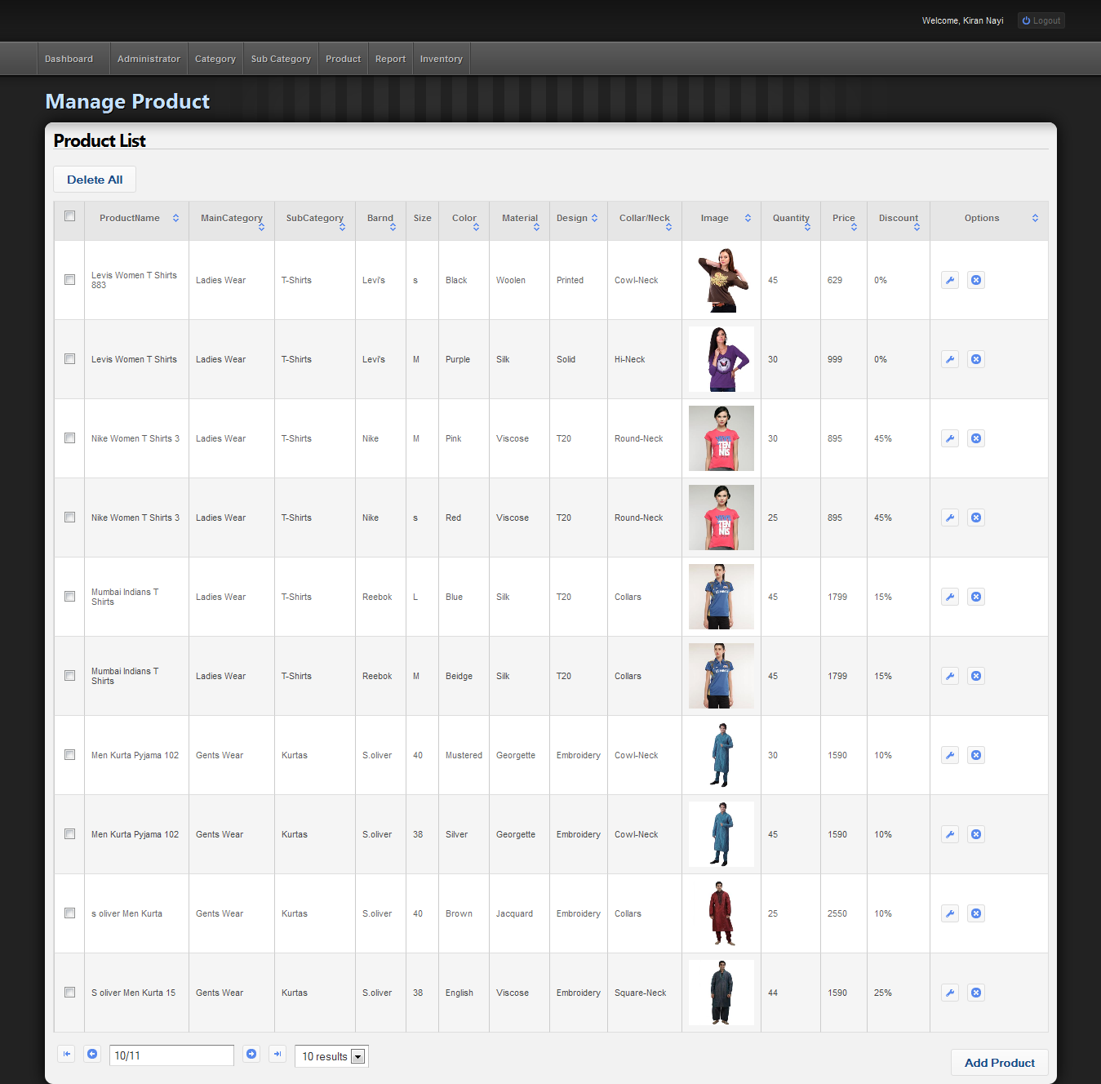

**48. Add New Product With Validation**

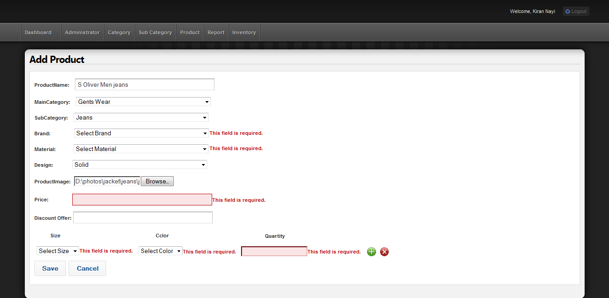

**49. Add New Product with Appropriate Data**

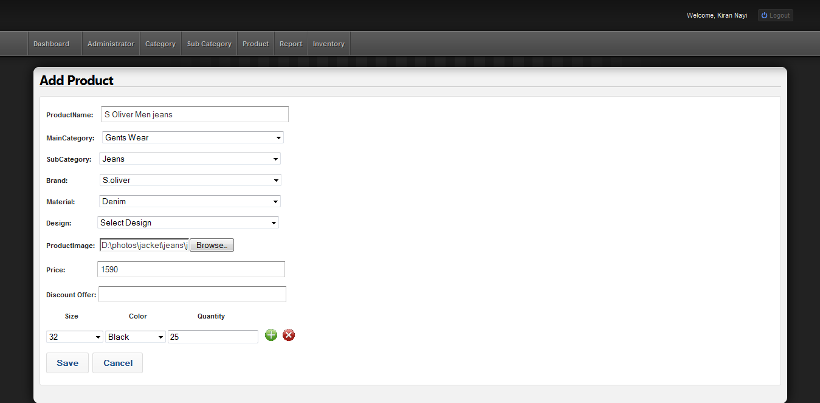

**50. New Product Added Successfully**

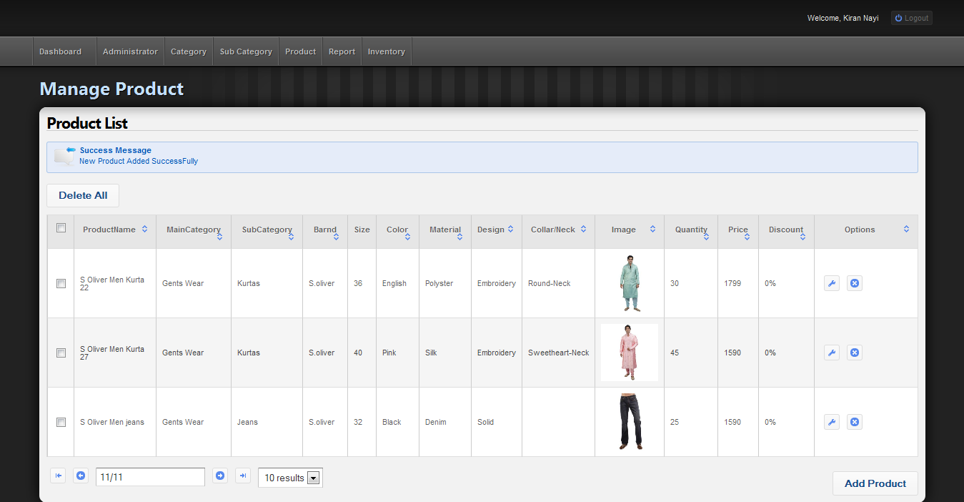

**51. Update Product**

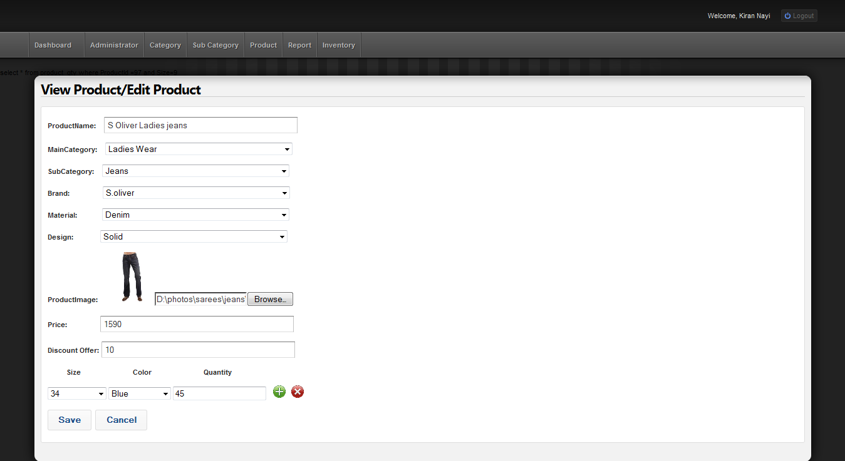

**52. Product Update**d **Successfully**

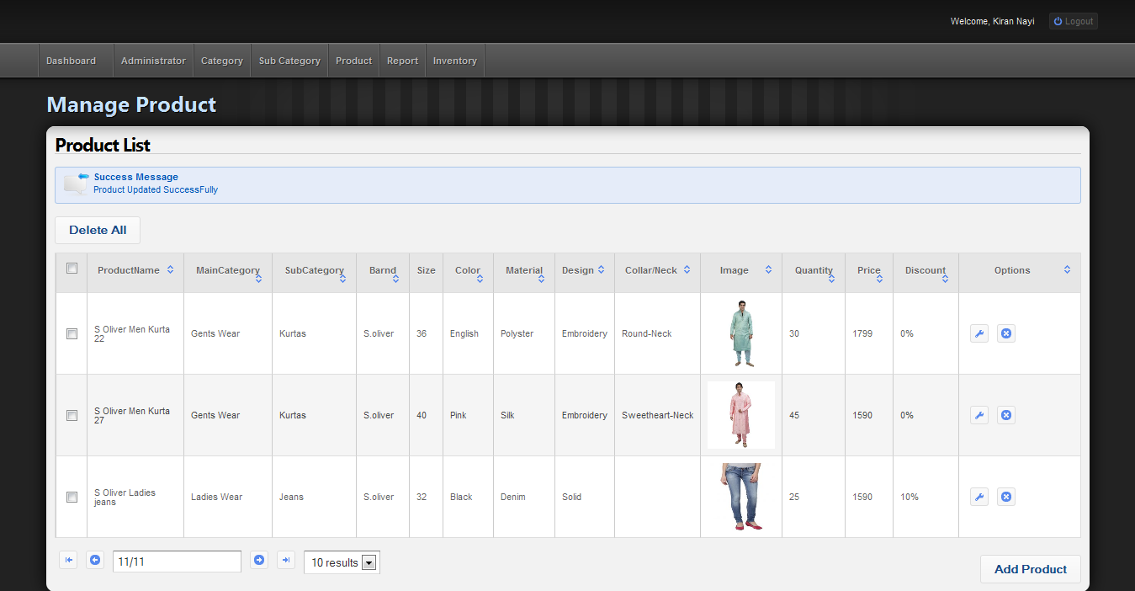

**53. Delete Product**

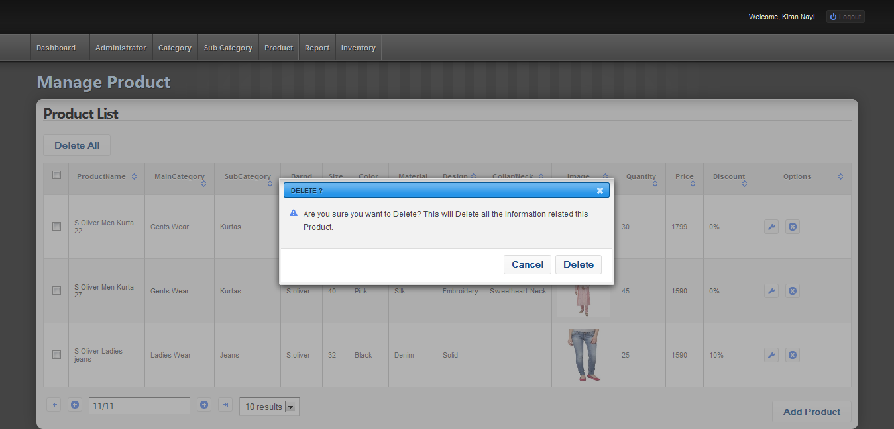

**54. Product Deleted Successfully**

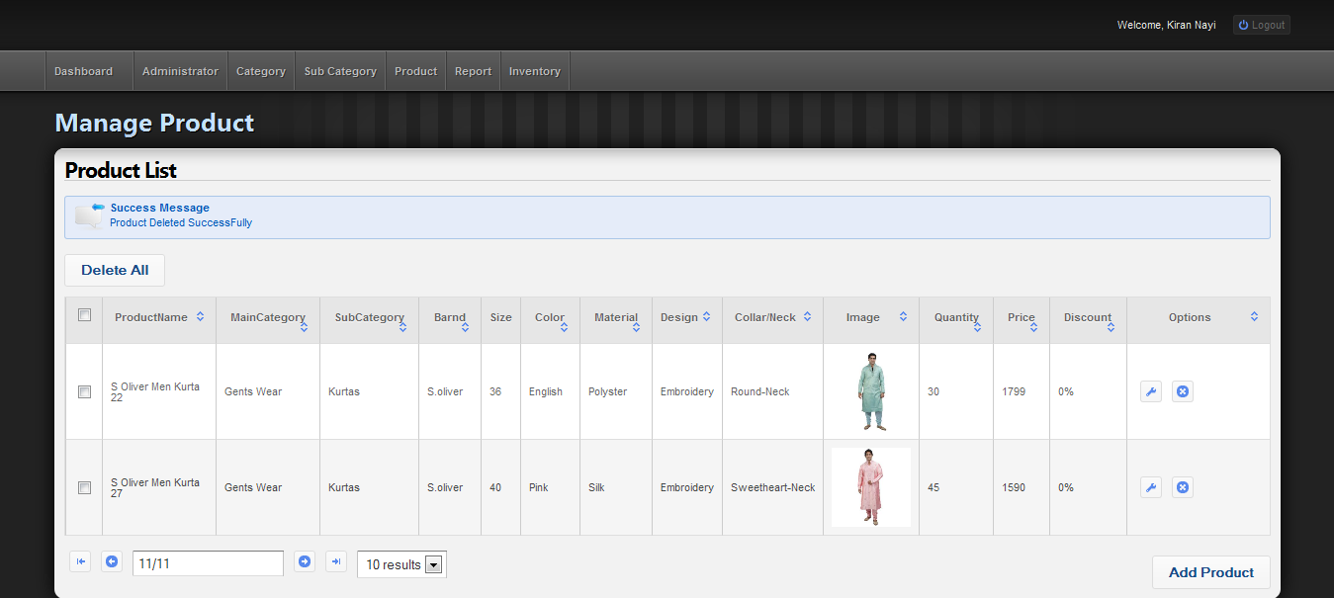

**55. Select Report from Dropdown**

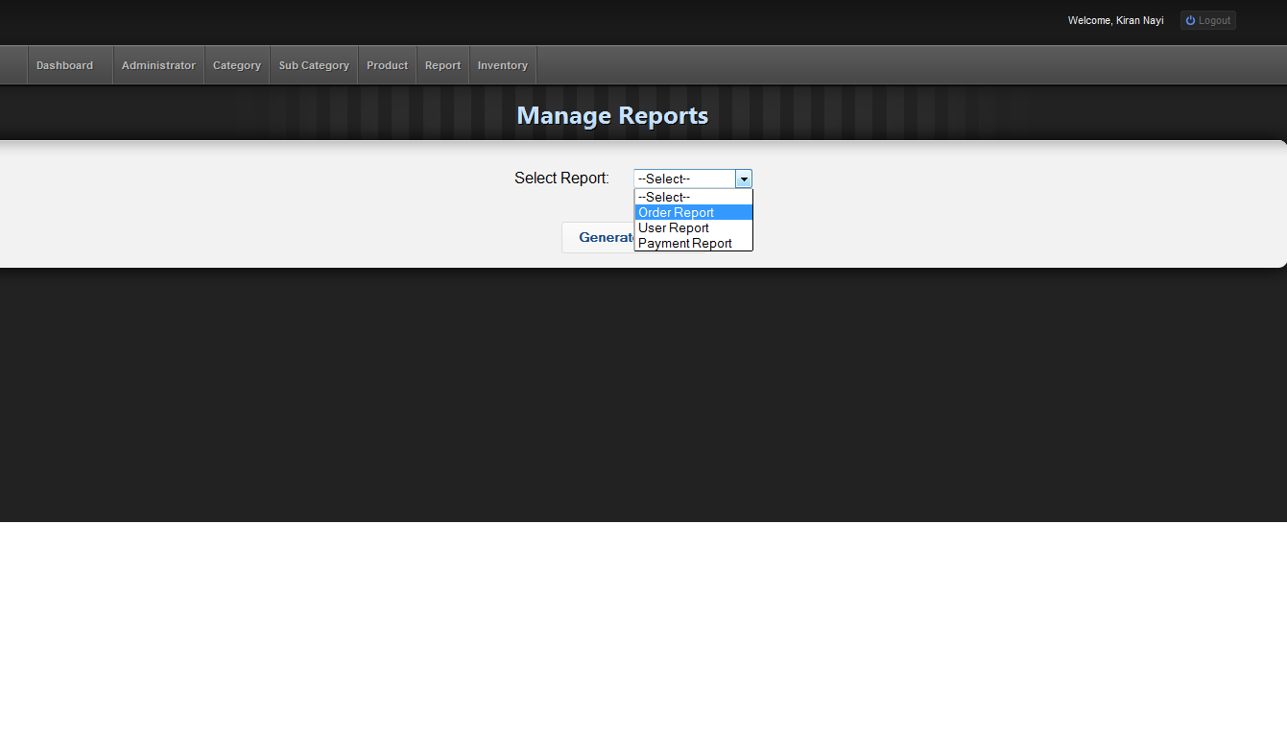

**56. Order Report**

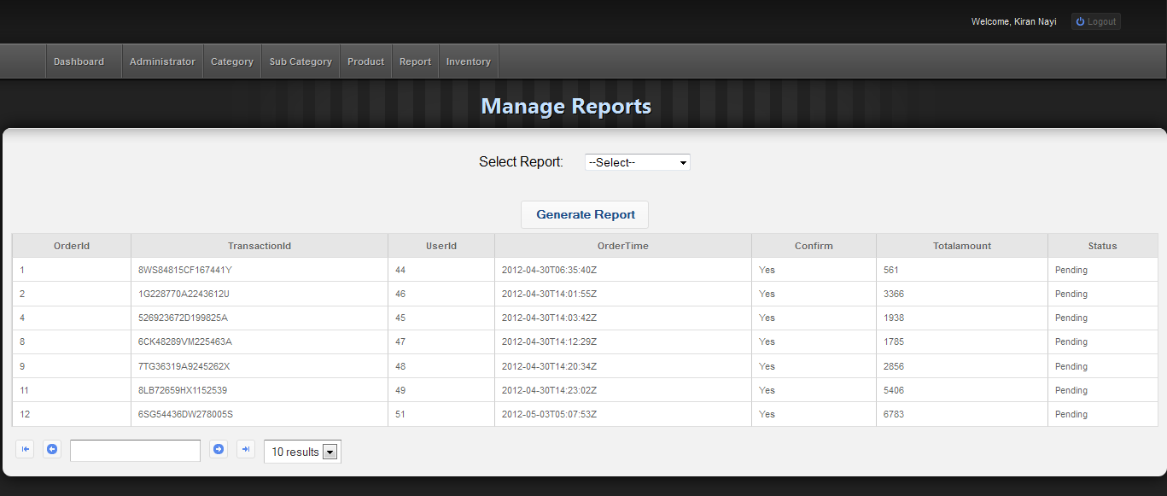

**57. Generate Order Report**

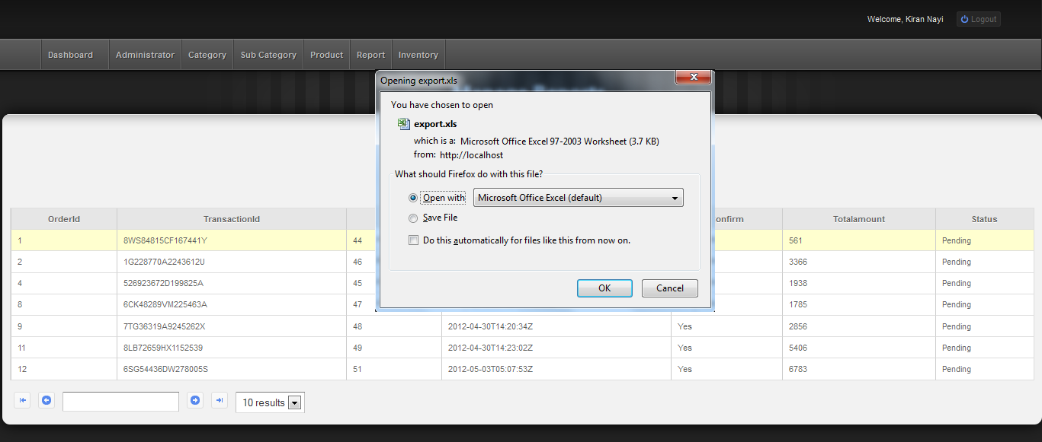

**58. Order Report**

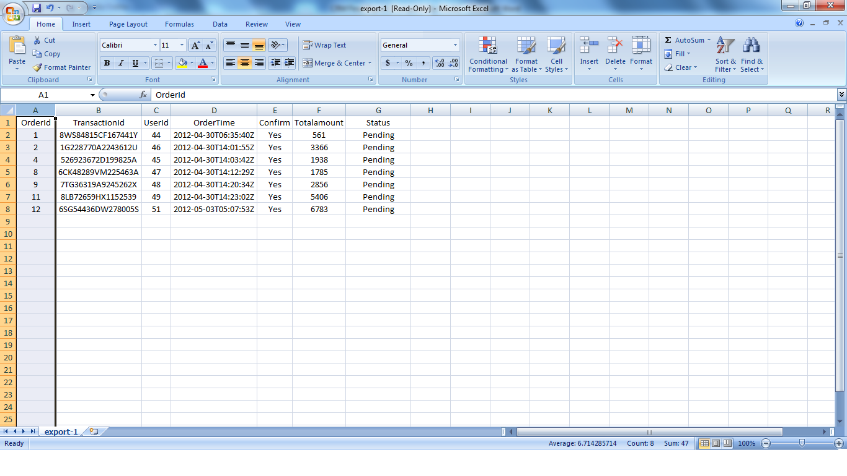

**59. User Report**

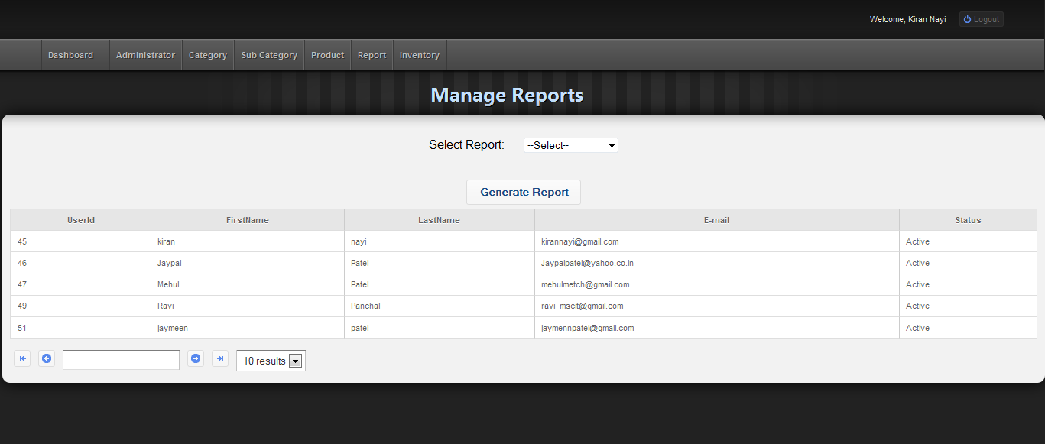

**60. Payment Report**

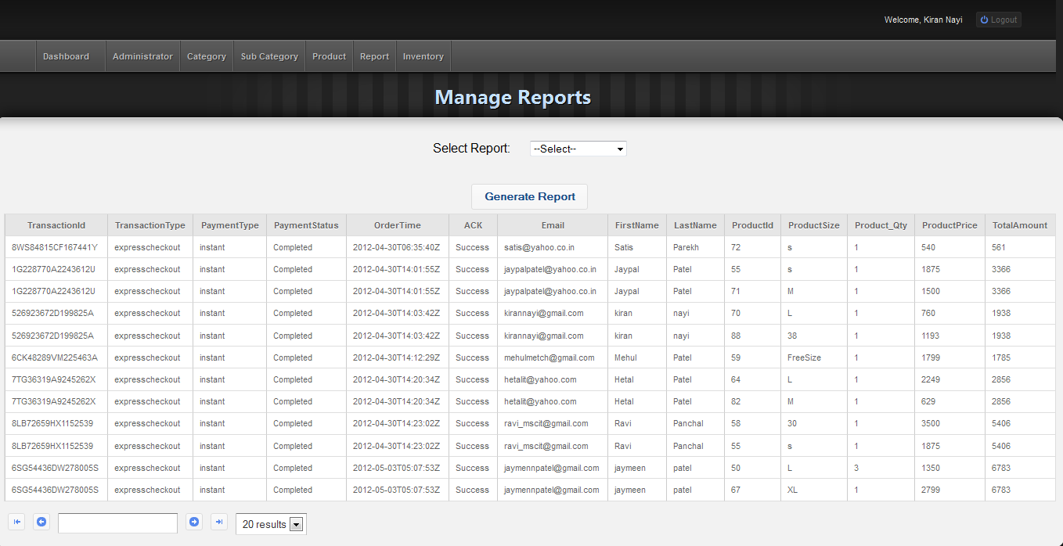

**TESTING 7**

**7.1 TESTING PLAN**

Testing is the process carried out on software to detect the differences between its behavior and the desired behavior as stipulated by the requirements specifications. Testing is advantageous in several ways. Firstly, the defects found help in the process of making the software reliable. Secondly, even if the defects found are not corrected, testing gives an idea as to how reliable the software is. Thirdly, over time, the record of defects found reveals the most common kinds of defects, which can be used for developing appropriate preventive measures such as training, proper design and reviewing

The testing sub-process includes the following activities in a phase dependent manner:

1. Create Test Plans.
2. Create Test Specifications.
3. Review Test Plans and Test Specifications.
4. Conduct tests according to the Test Specifications, and log the defects.
5. Fix defects, if any.
6. When defects are fixed continue from activity.

**UNIT**

TESTINGG

**MODULE**

TESTING

**SUB-SYSTEM**

TESTING

**SYSTEM**

TESTING

TESTINGG

**ACCEPTANCE**

TESTING

**7.2 TESTING STRATEGY**

The development process repeats this testing sub-process a number of times for the following phases.

1. Unit Testing.
2. Integration Testing

Unit Testing tests a unit of code (module or program) after coding of that unit is completed. Integration Testing tests whether the various programs that make up a system, interface with each other as desired, fit together and whether the interfaces between the programs are correct. System Testing ensures that the system meets its stated design specifications. Acceptance Testing is testing by the

users to ascertain whether the system developed is a correct implementation of the Software Requirements Specification.

Testing is carried out in such a hierarchical manner to ensure that each component is correct and the assembly/combination of components is correct. Merely testing a whole system at the end would most likely throw up errors in components that would be very costly to trace and fix.

We have performed both Unit Testing and System Testing to detect and fix errors. A brief description of both is given below.

### Unit Testing

The objective of Unit Testing is to test a unit of code (program or set of programs) using the Unit Test Specifications, after coding is completed. Since the testing will depend on the completeness and correctness of test specifications, it is important to subject these to quality and verification reviews.

* **Input:** Unit Test Specifications

**Testing Process**

* Checking for availability of Code Walk-thru reports which have documented the existence of and conformance to coding standards.
* Review of Unit Test Specifications
* Verify the Unit Test Specifications conform to the program specifications.
* Verify that all boundary and null data conditions are included.

**7.3 TESTING METHODS**

7.3.1 Black-box and White-box Testing

In black-box testing a software item is viewed as a black box, without knowledge of its internal structure or behavior. Possible input conditions, based on the specifications (and possible sequences of input conditions), are presented as test cases.

In white-box testing knowledge of internal structure and logic is exploited. Test cases are presented such that possible paths of control flow through the software item are traced. Hence more defects than black-box testing are likely to be found.

The disadvantages are that exhaustive path testing is infeasible and the logic might not conform to specification. Instrumentation techniques can be used to determine the structural system coverage in white box testing. For this purpose tools or compilers that can insert test probes into the programs can be used.

#### Code Coverage

The way to make sure that you have got all the control flow covered is to cover all the paths in the program during the testing (via white-box testing). This implies that both branches are exercised for an ‘if’ statement, all branches are exercised for a case statement, the loop is taken once or multiple times as well as ignored for a while statement, and all components of complicated logical expressions are exercised. This is called Path Testing. Branch Testing reports whether entire Boolean expression tested in control structures evaluated to both true and false

Additionally it includes coverage of switch statement cases, exception handlers and interrupts handlers. Path testing includes branch testing as it considers all possible combination of individual branch conditions. A simpler version is Statement Testing which determines if each statement in the program has been executed at least once. The coverage via Path Testing includes the coverage via Statement Testing. Since Path Testing is extremely comprehensive it is costly, hence a viable minimum should be measuring Statement Testing coverage.

**CONCLUSION 8**

**8.1 CONCLUSION**

* During the short period of six months we learned the art of living in professional environment, working in terms with full coordination and camaraderie. This application really taught me work like professionals in IT industry.
* When we started of with our project we soon came to know that water and waves in this sea was altogether different. It was merely uncharted proved out to be great counselors through out the voyage. It was my proved out to be great counselors throughout the voyage. It was my sincere effort backed by their guidance, which enabled me it, reach to the other shore. We really can’t find words to express our gratitude towards these great personalities.
* Our project is merely not a collection of few pages about the system that we have developed but embodies the whole spirit that enlivened through out the project. It enumerates the whole efforts right from the beginning to the end that formed the crux the project. This project made from the fabric of our team efforts.

BIBLIOGRAPHY 9

# Books:

* Beginning PHP And MySql

# Web Resource:

* [www.w3schools.com](http://www.w3schools.com)
* <http://php.net>
* [www.google.com](http://www.google.com) : To find out various topics on web.